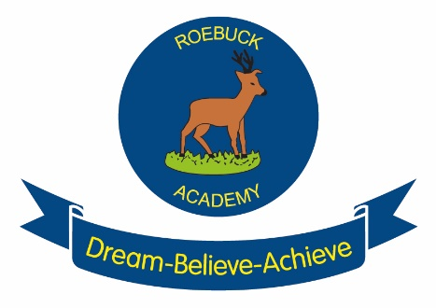
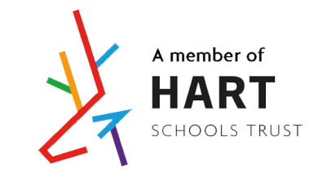

Phonic Policy

Introduction
At Roebuck School we aim to produce high quality phonic education that will help pupils to read and spell.

Approaches to Phonics:

At Roebuck we believe that phonics teaching should be:

• Systematic
• Discrete
• Interactive and multi-sensory
• Practical and engaging

Aims

- To enable children to learn phonic knowledge and skills with the expectation that they will become fluent readers, having secured word building and recognition skills, by the end of Key Stage One.
- To ensure that the children apply phonic knowledge as their first approach to reading and spelling, even though all words do not conform to regular phonic patterns.

Intent
- To ensure that children have opportunities to read texts and words that are within their phonic capabilities as early as possible, even though all words may not be entirely de-codable by the children unaided.
- To encourage the children to attempt to spell words for themselves, within the range of their phonic knowledge, by building the confidence and strategies to attempt the unfamiliar.
- To help the children to apply the skill of blending phonemes in order to read words.
- To help the children to segment words into their constituent phonemes in order to spell words.
- To learn that blending and segmenting words are reversible processes.
- To teach the children that phonemes should be blended from left to right through the complete word, in order for it to be read.
- Within the teaching of phonics, ensure that children are also taught an increasing amount of ‘Tricky Words’ which need to be learned by sight.

Implementation
- Our children are provided with a variety of opportunities to develop and extend their phonics skills in and across Nursery, Reception and Key Stage 1. It will also be continued into Key Stage 2, where necessary to support those children who do not yet have the phonic knowledge and skills they need.

- Planning: The school follows the systematic approach laid out in Letters and Sounds (DfE 2007) which we have adapted to meet the requirements of the new National Curriculum. Staff complete weekly plans for phonics which ensure progression and effective, high quality teaching.

- Lessons: Discrete phonics lessons take place daily across Reception and Key Stage 1. They follow the structure of ‘Review, Teach, Practise, Apply’ to ensure that children are consolidating phonic knowledge and skills over time and that they are able to apply them in context. Consequently, wherever possible, links between phonics knowledge and understanding are made to learning in both Reading and Writing. These lessons proceed at pace and incorporate a wide range of practical and interactive activities to engage the children. These activities are carefully chosen to ensure that children develop their skills in aural discrimination and phonemic and rhyme awareness, blending and segmenting as well as grapheme phoneme correspondence.

- Classes: Children are taught in class. They are taught the phase required for their year group however this work is underpinned with review and revisit of the previous phases and are regularly assessed and adapted by the class teacher. As children progress at different rates, we use interventions to support children who have larger gaps or misconceptions as an additional session.

- Resources: At Roebuck we use a multi-sensory approach through the scheme of monster phonics which links closely to letters and sounds. Through this scheme children will access their learning through a colour coded system that assigns each phoneme to a monster. Each lesson begins with a song, video or power point with the monsters and colour coding to support a range of different learning needs. In addition to this all staff have a range of resources to use which are appropriate for the level at which the children are working. They include practical resources and games sorted into phonic phases. These resources can be added to so that children are continually engaged with their learning and we encourage the use of games and hooks to engage the children in their learning. In each classroom in both Reception and Key Stage 1 the monsters are displayed as a working visual reminder of the graphemes. This display is used by the children to support the application of phonics in Reading and Writing in all aspects of the curriculum.

- Intervention: Children who still need extra support to develop their phonic knowledge across Key Stage 1 and 2 are identified and targeted for intervention. There are a range of intervention strategies which the school uses and the most appropriate one is selected once a child’s needs have been assessed.

Impact
- Assessment is regarded as an integral part of teaching and learning and is a continuous process. We strive to make our assessment purposeful, allowing us to match the correct level of work to the needs of the pupils, thus benefiting the pupils and ensuring progress. It is the class teacher’s responsibility to keep track of the progress made by all children in their class.

Assessment for Learning: We continually assess our pupils and recording their progress. Information for assessment is gathered in various ways: by talking to children, asking questions, observing their work, setting specific tasks. Teachers use this assessment information to plan further work into our lessons to address misconceptions and underpin current learning. We assess the children’s work in phonics by making informal judgements as we observe the children during lessons but children are also tested regularly to monitor their recall of graphemes, decoding through segmenting and blending and reading and spelling of high frequency or common exception words. The teacher then makes a summary judgement about the phase at which a child is secure and keeps a record on the tracker. This is kept in the class assessment file and analysed by the phonics leader and used to inform interventions required. We use this as the basis for assessing the progress of each child and we pass this information on to the next teacher at the end of the year. The assessments can identify areas of strength and weakness for a class, year group or whole school focus.

- Assessment of Learning: The attainment and progress of children in phonics is assessed regularly across the year, both discretely at the end of each term and through Reading and Writing assessments. At the end of Year 1, children participate in the phonics screening check which assesses their knowledge of grapheme phoneme correspondence and their skills in blending. This information is submitted to the LA. Those children who do not succeed in the phonics screening check are highlighted for further intervention and targeted support before completing the screening check again at the end of Year 2. For children who do not succeed a second time, provision is made for them to receive intervention and targeted support in Key Stage 2.

- Feedback: Children are provided with constructive and timely feedback in lessons. Teachers provide parents with feedback on their child’s progress and achievement at parent’s evening and through the end of year report. Assessment information is also passed onto the next teacher as part of transition between year groups and phases.

Monitoring and review

The subject leader is responsible for monitoring the standard of the children’s learning and the quality of teaching in Phonics. The phonic leader is also responsible for supporting colleagues in the teaching of phonics, for being informed about current developments in the subject, and for providing a strategic lead and direction for the subject in the school. The phonics leader is responsible for giving the Senior Management Team an annual summary report in which they evaluate the strengths in the subject and indicate areas for further improvement. The phonic leader has specially allocated time for fulfilling the vital task of scrutinising planning, analysing samples of children’s work, carrying out pupil voice interviews and visiting classes to observe teaching in the subject and observing the use of phonics in the learning environment.

Date: spring 2020
Review Date: Autumn 2021

