I believe I never truly loved anyone until this moment.
ROMEO
Let him stay. He isn’t causing any trouble.
Our enemy Romeo is here. We must fight him.
Oh Romeo, why must you be a Montague?
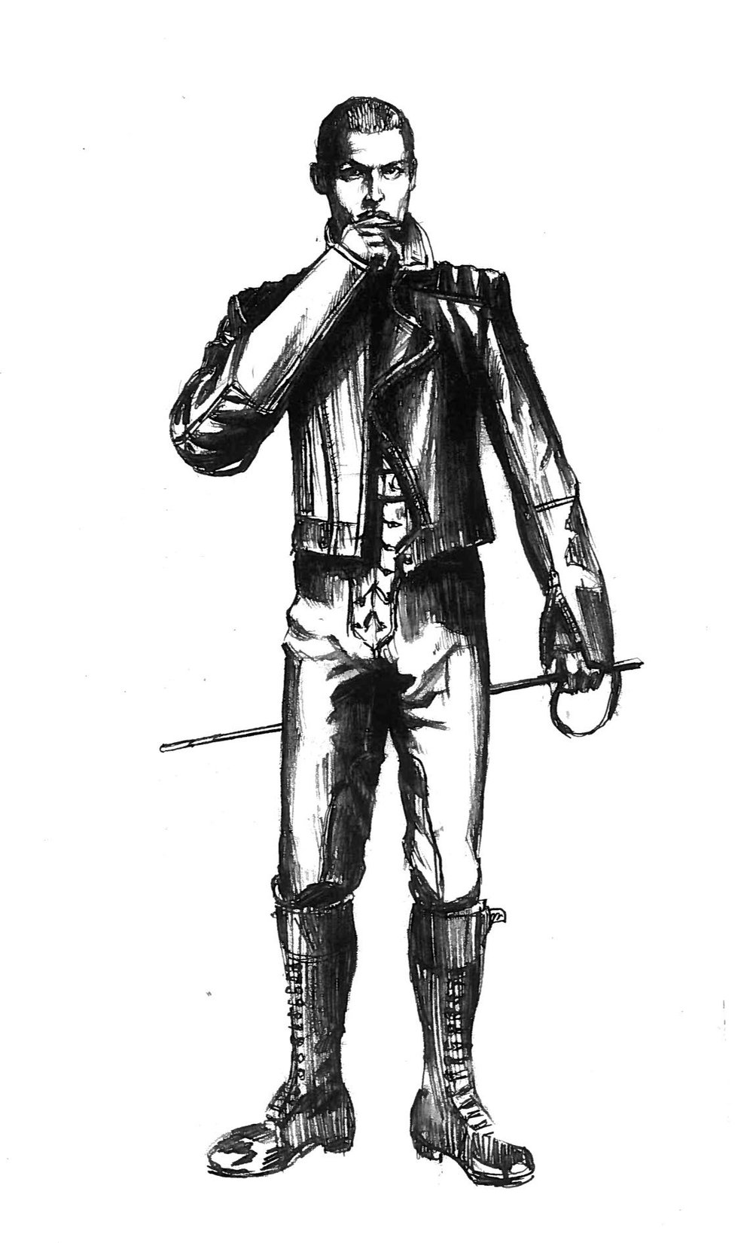
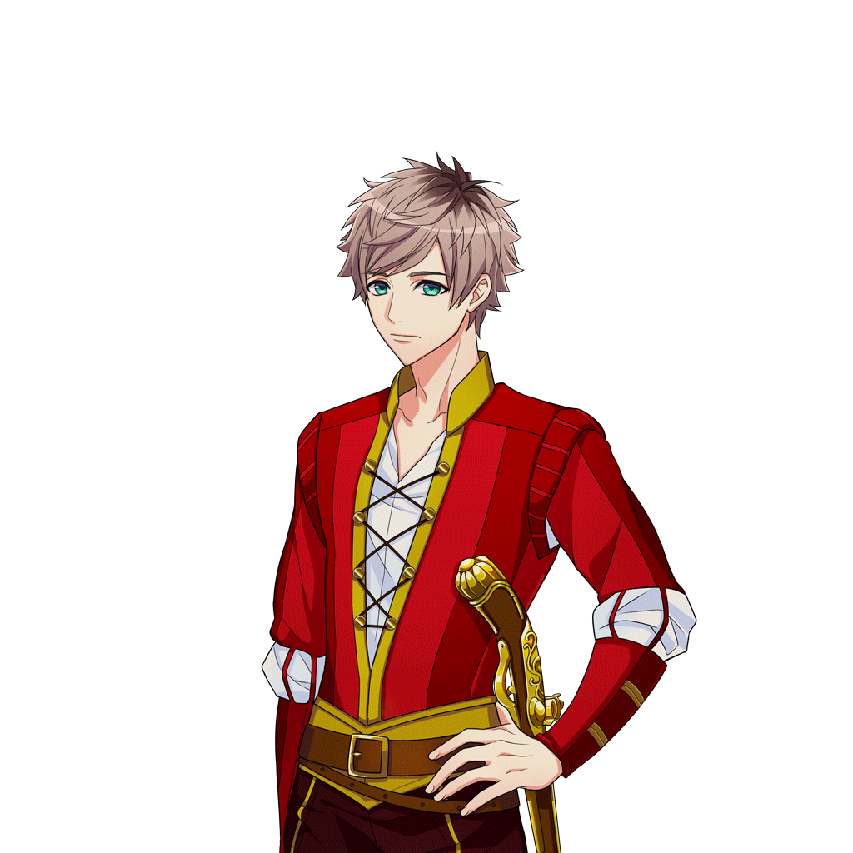
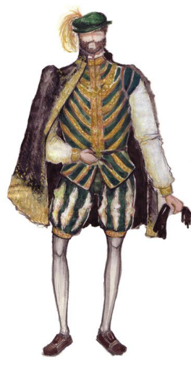

JULIET

TYBALT

LORD CAPULET

Look at the pictures of characters from Romeo and Juliet talking. Rewrite the sentences in speech bubbles using the correct punctuation and describing who said it.
Copy the sentences below into your books putting speech marks in the right places.
Vary the ways in which the speech in your sentences is presented.
Examples:
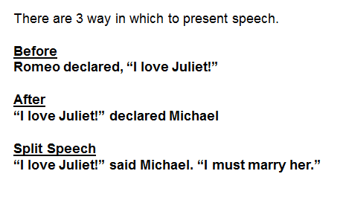
- Tybalt thundered our enemy, Romeo is here
- Lord Capulet replied if you won’t obey me then it is you who must leave
- The nurse said your mother wants to speak to you. You must go at once
- Juliet said my love for you is real. If yours is too, then let us be married
- Benvolio urged run, get away. I’ll explain everything

Extension: Write sentences using these words instead of ‘said’.

- Declared
- Growled
- Sighed
- Gasped
- Cried
- Protested
- Shouted
- Replied
- Insisted
- thought

