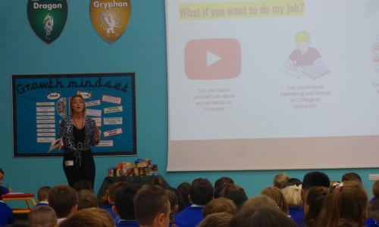

Roebuck Academy hosted it's latest Dream catcher assembly, which saw Leanne Merrill, who works for the Sun newspaper as a social media digital editor, tell the children about her work. Her job includes looking after the social media streams such as Facebook, Twitter and Instagram and as part of her job she makes short films to advertise certain features on these platforms. As part of her work she has also met a lot of celebrities at launch events and regularly "chats" to over 4 million followers on the various social media streams. To be able to do her job she said that she had to get good grades in Maths and English and she started out by hosting her own blog about makeup and hair. When asked what nugget of wisdom she would give the children, she said that to achieve success in whatever they wanted the children should not stop trying to get better in whatever they wanted to do.

