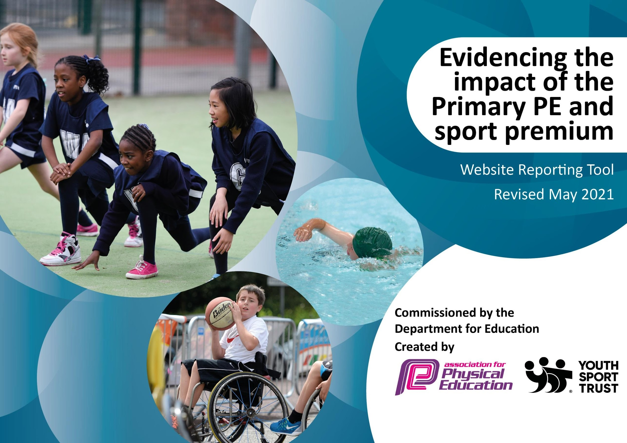

It is important that your grant is used effectively and based on school need. The Education Inspection Framework (Ofsted 2019 p64) makes clear there will be a focus on ‘whether leaders and those responsible for governors all understand their respective roles and perform these in a way that enhances the effectiveness of the school’.

Under the Quality of Education criteria (p41) inspectors consider the extent to which schools can articulate their curriculum (INTENT), construct their curriculum (IMPLEMENTATION) and demonstrate the outcomes which result (IMPACT).

To assist schools with common transferable language this template has been developed to utilise the same three headings which should make your plans easily transferable between working documents.

Schools must use the funding to make additional and sustainable improvements to the quality of Physical Education, School Sport and Physical Activity (PESSPA) they offer. This means that you should use the Primary PE and sport premium to:

- Develop or add to the PESSPA activities that your school already offer
- Build capacity and capability within the school to ensure that improvements made now will benefit pupils joining the school in future years
- The Primary PE and sport premium should not be used to fund capital spend projects; the school’s budget should fund these.
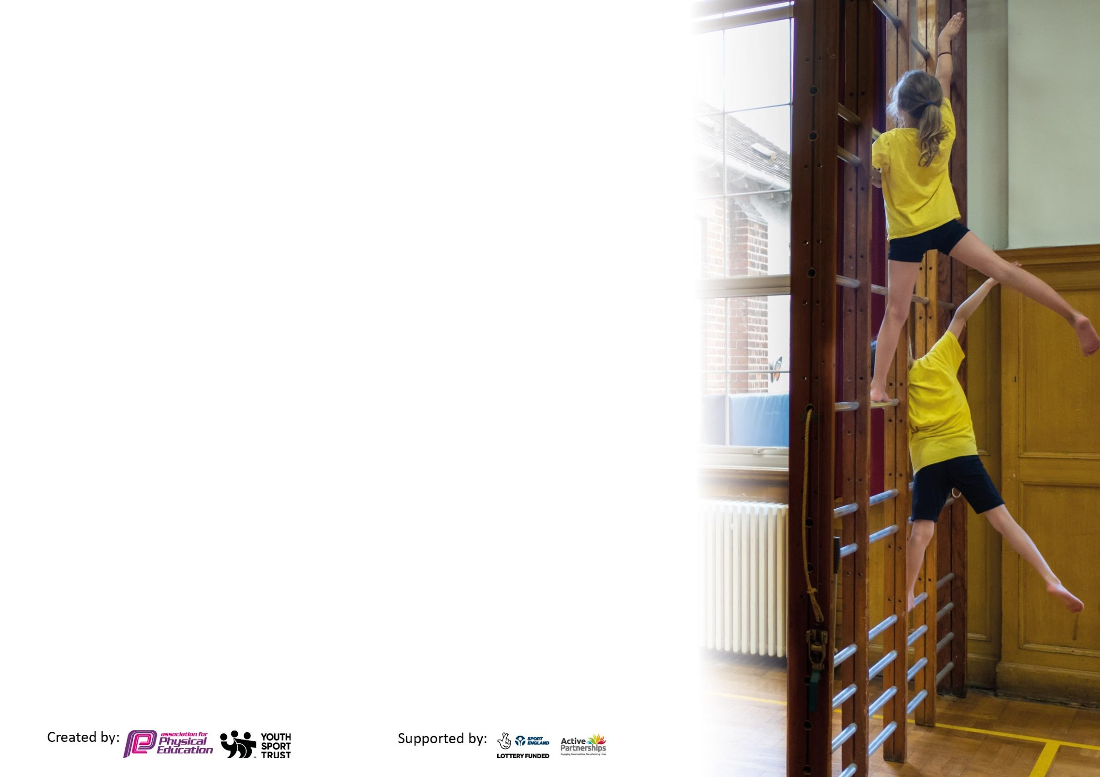
Please visit gov.uk for the revised DfE guidance including the 5 key indicators across which schools should demonstrate an improvement. This document will help you to review your provision and to report your spend. DfE encourages schools to use this template as an effective way of meeting the reporting requirements of the Primary PE and sport premium.

We recommend you start by reflecting on the impact of current provision and reviewing the previous spend.

Schools are required to publish details of how they spend this funding, including any under-spend from 2019/2020, as well as on the impact it has on pupils’ PE and sport participation and attainment by the end of the summer term or by 31st July 2021 at the latest.

We recommend regularly updating the table and publishing it on your website throughout the year. This evidences your ongoing self-evaluation of how you are using the funding to secure maximum, sustainable impact. Final copy must be posted on your website by the end of the academic year and no later than the 31st July 2021. To see an example of how to complete the table please click HERE.



Please note: Although there has been considerable disruption in 2020 it is important that you publish details on your website of how you spend the funding - this is a legal requirement.

Support for review and reflection - considering the 5 key indicators from DfE, what development needs are a priority for your setting and your pupils now and why? Use the space below to reflect on previous spend and key achievements and areas for development.

N.B. In this section you should refer to any adjustments you might have made due to Covid-19 and how these will influence further improvement.
Key achievements to date until July 2021: | Areas for further improvement and baseline evidence of need:
We have continued to provide CPD opportunities for staff.  We have continued to provide children from YN - Y6 with the opportunity to participate in street dance sessions.  We have continued to provide sports tuition for pupils in Nursery and Reception classes.  We have continued to provide and develop extra-curricular clubs during after school and lunchtime. These have increased since the previous academic year.  We have held ‘well-being’weeks in school, promoting fitness, positive mental health and well-being for pupils and staff.  We have entered a wide range of virtual competitions, including Basketball, Football and Multi-Sports events. | Make efforts to provide sports interventions for targeted pupils by allocating the sports specialist to narrow the gap in physical fitness.  To develop half termly physical challenges across the school, tracking progress by entering results and monitoring completion of this.  Continue to fund additional extracurricular costs for those children who are disadvantaged.  To ensure that the current Year 6 are given the opportunity to achieve Levels 1 and 2 in Bikeability (when safe to do so). To ensure that the current Year 4 are given the opportunity to achieve Level 1 in Bikeability (when safe to do so).  Provide opportunities for scooter workshops for children in school - purchasing of class set of scooters  To offer a wider range of extra-curricular sporting activities, including ‘lesser known’ sports.  To enter a ‘B’ Team in at least one competition.

Did you carry forward an underspend from 2020-21 academic year into the current academic year? NO * Delete as applicable
Total amount carried forward from 2020/2021 £0
+ Total amount for this academic year 2020/2021 £19,500 Approx based on Y1 - Y6 £16000 plus costing based on 350 pupils Total: £19500
= Total to be spent by 31st July 2022 £19,500

Meeting national curriculum requirements for swimming and water safety.  N.B Complete this section to your best ability. For example you might have practised safe self-rescue techniques on dry land which you can transfer to the pool when school swimming restarts.  Due to exceptional circumstances priority should be given to ensuring that pupils can perform safe self rescue even  if they do not fully meet the first two requirements of the NC programme of study. | NA at present
What percentage of your current Year 6 cohort swim competently, confidently and proficiently over a distance of at least 25 metres?  N.B. Even though your pupils may swim in another year please report on their attainment on leaving primary school at the end of the summer term 2021.  Please see note above. | %
What percentage of your current Year 6 cohort use a range of strokes effectively [for example, front crawl, backstroke and breaststroke]?  Please see note above. | %
What percentage of your current Year 6 cohort perform safe self-rescue in different water-based situations? | %
Schools can choose to use the Primary PE and sport premium to provide additional provision for swimming but this must be for activity over and above the national curriculum requirements. Have you used it in this way? | Yes/No

Roebuck Academy
Sports Premium Spending 2021 - 2022

Sports Premium Overview
At Roebuck Academy we believe that PE and Sporting opportunities play a crucial and critical role in helping children to develop healthy and active children, with the potential to change young people’s lives for the better.
At Roebuck Academy, we recognise the contribution of PE and sport to the health and well-being of the children. We believe that an innovative, varied PE curriculum and extra-curricular opportunities have a positive influence on the concentration, attitude and academic achievement of all our children.
Our Primary School Sport’s Funding enables us to continue to extend our provision through employing additional sports professionals as appropriate, entering into more sports competitions and training our staff to deliver in-house quality PE lessons.
The senior leadership team and PE sporting team are committed to ensuring that all pupils receive at least two hours of high-quality, well planned and resourced PE sessions per week, delivered by confident and well-trained teachers and coaches. The successful delivery of our sporting curriculum supports all aspects of health education within the school.
In addition to the two hour PE recommendation, the school will take part in a ‘daily mile’ initiative. This will consist of a 20 minute session each day exercising around a marked track. In the Spring Term, we shall also be implementing a ‘half termly’ challenge, which will allow the children to practice a small key skill every week that half term, with the view of improving their score / skill / time each time. Scores will be tracked by the pupils and class teachers, with time given in PE sessions to further develop these skills.

Primary School’s Sports Funding
Click here for the Department of Education link to the Primary School’s Sports Funding page.
What is the Sports Premium?
The Sports Premium is an allocation of additional funding provided to schools each year to improve provision of Physical Education (PE) and sport in primary schools. This funding is provided jointly by the Departments for Education, Health and Culture and Media and Sport. The aim of the funding is to improve the quality of sport and PE for all children. Each school will receive approx. £16,000 plus £10 per pupil for all children in Years 1 – Year 6 in 2021/22.
The funding can only be spent on sport and PE provision and is part of the 2012 Olympic legacy which had such a massive impact upon our lives in this country.
We have seen a massive improvement in the teaching of PE since this initiative began in 2013 because we have had the funding to employ specialists who work closely with our teachers’ week on week which has had a strong impact upon teacher’s teaching. The children have enjoyed and benefited from a range of sports which will continue because we are 100% committed to providing the best sporting opportunities that we can year on year

Purpose of the funding:
Schools have to spend the sport funding on improving their provision of PE and sport, but we have the freedom to choose how we do this.
Possible uses of the funding include:
Hiring specialist PE teachers or qualified sports coaches to work alongside primary teachers when teaching PE
New or additional sport clubs
Paying for professional development opportunities in PE/sport
Providing cover to release primary teachers for professional development in PE/sport
Running sport competitions, or increasing participation in the school games
Buying quality assured professional development modules or material for PE/sport
Providing places for pupils on after school sport clubs and residential visits
Sports funding – How has it been used?
Roebuck Academy is committed to using the Sports Premium in the best possible way. So far, the Academy has strived to:
Work in a collaborative partnership with Stevenage Sporting Futures Trust (SSFT) where all children are fully involved in a variety of sporting experiences, festivals and competitions.
Take advantage of regular training and support offered from SSFT staff.
Employ a Sports Specialist Teaching Assistant to work in the school for five days a week, both supporting and leading in PE lessons and extra-curricular activities.
Provide the Sports Specialist Teaching Assistant with target groups of children to develop their skills in PE and sport.
Provide training and funding to enable midday supervisors to deliver a variety of playground games during lunchtimes.
Provide children in Year 5 and 6 with training to ensure that they are able to lead sporting activities at lunch and break times.
Provide all children in Key Stage 1 and Key Stage 2 with junior membership to the Supporters Association of the local football club. This gives the children the opportunity to be a match day mascot; provides them with regular information about living a healthy and sporting lifestyle; and gives the children 15% discount at many sport and fitness clubs / shops in the local area.
Forge strong links with the PE subject leader at Thomas Alleyne's Academy to help improve PE provision across the school and trust.
Employ a specialist sports coach/es to improve the quality of Teaching and Learning of PE at the school
Improve the PE and fitness equipment at the school to improve the provision offered
Improve and extend the range of extra-curricular sporting clubs on offer at the school

Action Plan and Budget Tracking
Capture your intended annual spend against the 5 key indicators. Clarify the success criteria and evidence of impact that you intend to measure to evaluate for pupils today and for the future.

Academic Year: 2021/22 | Total fund allocated: £19,500 | Date Updated:
Key indicator 1: The engagement of all pupils in regular physical activity – Chief Medical Officers guidelines recommend that primary school pupils undertake at least 30 minutes of physical activity a day in school |  |  |  | Percentage of total allocation:
 |  |  |  | 100 and above %
Intent | Implementation |  | Impact
Your school focus should be clear what you want the pupils to know and be able to do and about  what they need to learn and to  consolidate through practice: | Make sure your actions to achieve are linked to your intentions: | Funding allocated: | Evidence of impact: what do pupils now know and what can they now do? What has changed?: | Sustainability and suggested next steps:
Provision of specialist sports coaches working with all classes during the week in school.  Staff attending relevant Sport CPD provided by SSFT or other provider | Full Time Sports coach and dance teacher work to focus on delivery of high standards of teaching in PE | £9000 Sports Coach  £4560 |  | 70% of total allocation
Weekly/Monthly Fitness challenges to be implemented throughout the academic year, designed to keep children more active during the school day. | PE Lead to introduce a fitness challenge each month and teacher to monitor a start/finish score.  Data to be provided to subject leader at the end of each half term | £200 |  | 1% of total allocation
Narrow the gender and SEND gap in PE which exist in Physical Education and Sport.  Increase the provision for Pupil Premium children to attend sports clubs.  Purchase and provide equipment for both PE sessions and playtimes. | Targeted interventions will be put in place for those in need based on SEND / Gender assessment data. These will meet social and physical needs of the pupils. Teachers implement support for these children in PE Sessions when the lead coaches are teaching.  Offer a range of extra-curricular opportunities for sport (Football, Netball, Cricket, Multi-Sports, Basketball). Increase % of children attending these clubs  Pupil voice to gain interest (what are you interested in? What’s stopping you?)  Audit resources currently available. What needs replenishing? How can the current provisions be expanded to accommodate larger zones?  Purchase additional equipment to support expansion of provision at the school ex: Fencing, archery, scootability equipment etc | £1000  £As part of the additional costing of a Sports coach  £2000  £2000 |  | 5% of total allocation  10% of total allocation  10% of total allocation
Provide opportunities for scooter workshops for children in school- purchasing of class set of scooters | Organising scooter workshops for children in school as part of healthy lifestyles, walk/ riding to school and school travel plan  Purchasing a set of class scooters and safety equipment. | £500  £1500 - £100 per scooter = 15 scooters plus helmets - £450 |  | 2.5% of total allocation  10% of total allocation
Key indicator 2: The profile of PESSPA being raised across the school as a tool for whole school improvement |  |  |  | Percentage of total allocation:
 |  |  |  | 22%
Intent | Implementation |  | Impact
Your school focus should be clear what you want the pupils to know and be able to do and about  what they need to learn and to  consolidate through practice: | Make sure your actions to achieve are linked to your intentions: | Funding allocated: | Evidence of impact: what do pupils now know and what can they now do? What has changed?: | Sustainability and suggested next steps:
Improve the physical and wellbeing choices for children at playtimes. | Young Sports Leaders trained and developed (with the help of SSFT) to lead and encourage more physical activity in playtime sessions.  Provide equipment to enrich the experiences of playtimes and provide teaching of games and activities to encourage games.  Provide more ‘in-house’ continuous training for leaders and encourage more participation for children and leaders in team games. | Part of SSFT package).  PE Lead to be allocated time with sports leaders weekly.  £4240per academic year for SSFT  £236 (play equipment) |  | 22% of total allocation
Monitoring of children with higher levels of sporting competence to enable staff to signpost these children to external clubs, developing their skills outside of school. | Register of more able/talented children to be monitored by sports lead. Teachers are encouraged to signpost any G&T children in any particular area of PE to PE lead so he can provide extra opportunities (local clubs, trial days etc). | N/A
Complete regular ‘in house’ challenges and competitions to be put on the website/newsletter to raise the profile of sport in school. | Challenges to be completed in classes regularly throughout the year. Photos to be taken and celebrated on the website/newsletter/ social media i.e Twitter. | N/A
Celebration of national sports weeks to raise the profile of sports and improve the image of sport in school. | Plan to include a range of activities across classes in a week to mirror events in the sporting calendar. Publicise events on website and social media. | £250

Key indicator 3: Increased confidence, knowledge and skills of all staff in teaching PE and sport |  |  |  | Percentage of total allocation:
 |  |  |  | 5%
Intent | Implementation |  | Impact
Your school focus should be clear | Make sure your actions to | Funding | Evidence of impact: what do | Sustainability and suggested
what you want the pupils to know | achieve are linked to your | allocated: | pupils now know and what | next steps:
and be able to do and about | intentions: |  | can they now do? What has
what they need to learn and to |  |  | changed?:
consolidate through practice:
Staff attending relevant Sport CPD provided by SSFT or other provider  Provide CPD for orienteering/ circuits fitness for staff | Staff confident delivering PE sessions, ensuring they are of a high quality.  CPD for orienteering/ fitness circuits for staff in school – developing an orienteering course for pupils in school. | £1000 for staff cover |  | 5% of total allocation
Provision of a dance teacher working with all classes during the week in school. | Dance teacher work alongside teachers to focus on delivery of high standards of teaching and providing on high quality CPD for staff | £4560 |  | 23% of total allocation
Key indicator 4: Broader experience of a range of sports and activities offered to all pupils |  |  |  | Percentage of total allocation:
 |  |  |  | 45%
Intent | Implementation |  | Impact
Your school focus should be clear | Make sure your actions to | Funding | Evidence of impact: what do | Sustainability and suggested
what you want the pupils to know | achieve are linked to your | allocated: | pupils now know and what | next steps:
and be able to do and about | intentions: |  | can they now do? What has
what they need to learn and to |  |  | changed?:
consolidate through practice:
Additional achievements:
Swimming –PE & Healthy Active Lifestyles  (planned in for Spring or Summer Term 2022 depending on COVID guidelines – Year 5 class who missed swimming - if not able to, Autumn Term when in Year 6.)  Specialist Dance coaching –PE & Healthy Active Lifestyles  Bikeability training  Increase opportunities for outdoor learning-Orienteering | To provide additional funding to help subsidise the cost of swimming-ensure a high % of children achieve 25 Meters at the end of year 6.  To provide all children with specialist dance classes  Provide children with subsidised places for Level 1 and 2 Bikeability  Provide an orienteering course with plaques and teaching resources to run own sessions. | £3000  Already costed  £3000  Approx £1000  (dependent on school size) |  | 15% of total costing  Already costed  15% of total costing  5% of total costing
Offer added opportunities for new sports through the academic year- badminton, Volleyball | Through use of sports coach/ Subject lead deliver new sports to year groups.  Purchase of relevant equipment for sports introduced  Increase participation of children in newly introduced sports- badminton, volleyball. | £1000 |  | 5% of total costing
Raise profile of PE that were in Olympics: | BMX day- Mike MullinsBMX day for all children- assemblies linked to Growth Mindet and school values,  Scootability sessions and workshops etc | £570  £500(as above) |  | 2.5%  2.5%

Key indicator 5: Increased participation in competitive sport |  |  |  | Percentage of total allocation:
 |  |  |  | 2.5%
Intent | Implementation |  | Impact
Your school focus should be clear | Make sure your actions to | Funding | Evidence of impact: what do | Sustainability and suggested
what you want the pupils to know | achieve are linked to your | allocated: | pupils now know and what | next steps:
and be able to do and about | intentions: |  | can they now do? What has
what they need to learn and to |  |  | changed?:
consolidate through practice:
Stevenage Sporting Futures Trust – Competitive Sport  Aim to attend as many competitions as possible when permitted (Covid Guidelines).  Entered 2 football and 1 Netball teams into leagues that run throughout the year. Aim to provide ‘B’ Teams in sports when achievable  Offer a wider range of sporting clubs after school | To enable all children to participate in competitive games, sporting events and competitions in Stevenage.  The children in Year 5 and 6 were given the opportunity to participate in competitive games.  Provide a wide range of after school clubs based on children’s interests.  Link clubs to activities/ events organised by SFT and ensure participation of Roebuck in relevant festivas. | £4240  £70(league entry)  Free |  | Already costed  No impact to budget - minimal
Complete regular ‘in house’ challenges and competitions to be put on the website/newsletter to raise the profile of sport in school. | Challenges to be completed in classes regularly throughout the year. Photos to be taken and celebrated on the website/newsletter.  House competitions through classes/Key Stages | £500 |  | 2.5% of total costings
Offer added opportunities for new sports through the academic year- badminton, Volleyball | Through use of sports coach/ Subject lead deliver new sports to year groups.  Purchase of relevant equipment for sports introduced  Increase participation of children in newly introduced sports- badminton, volleyball. | £1000 |  | Already costed

Signed off by
Head Teacher: | Ms Lynsey Young
Date: | July 2021
Subject Leader: | Shaun Downie,Andy Mari, Connor Moran
Date: | July 2021
Governor: | To be approved by GB September 2021
Date: | 23rd September 2021

