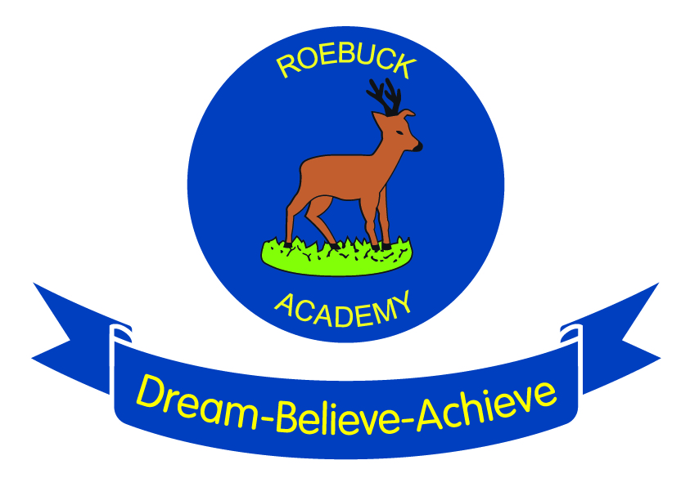

Reading
at Roebuck

Reading provision at Roebuck
Reading is a key priority at Roebuck. We believe that all children should leave our school with a love of reading and be equipped with the skills that they need for their futures. Reading at home is celebrated weekly in achievement assembly, with a trophy for classes with the highest percentage of children reading 5 days or more a week. Every opportunity is taken to make links with visiting authors and other schools to promote a love of reading.

Promoting a love of reading
Every classroom has an inspiring book corner where children are able to immerse themselves in a range of different text types. A designated time is given each day for teachers to read to their class -sharing favourite poems, picture books and class novels. Classes also pair up with one another to spend time sharing books across different age groups. The school’s library has recently been relaunched with shelves brimming with new books and information about some of the authors. As well as this, a new seating area for children provides a comfy area for them to lose themselves in a book. Everybody is responsible for looking after the library and a team of eager Year 6 librarians ensure the shelves remain tidy. The library is also open to parents and children before and after school on certain days.

Providing quality teaching of reading
Daily guided reading sessions ensure that all children are read with in a small group at least once a week, allowing the teacher to continuously assess and monitor their progress. Pre-reading of the text before the guided session enables children to engage with the text, understand the purpose and audience and clarify understanding of unfamiliar vocabulary. Consequently, guided taught sessions can focus on specific reading skills which need to be taught such as retrieving, deducing and inferring. A follow up task also allows the children to respond to the text independently and become familiar with test style questions.

Assessing progress in reading
As well as quality teacher assessment, the Key Stage 2 children are assessed on a half-termly basis using a scheme called Accelerated Reader. Children answer a range of different computer generated questions in order for their reading age and ability to be determined. They are then given a book level which helps them to select books at the right level of challenge for them. Children can then take a book quiz, which allows teachers to assess their understanding of both the text and vocabulary.
From Years 1 to 6, children undertake a termly reading paper which supports teacher assessment and gives children the opportunity to prepare for end of Key Stage tests. Gaps from these tests are identified to inform future teaching sessions.

