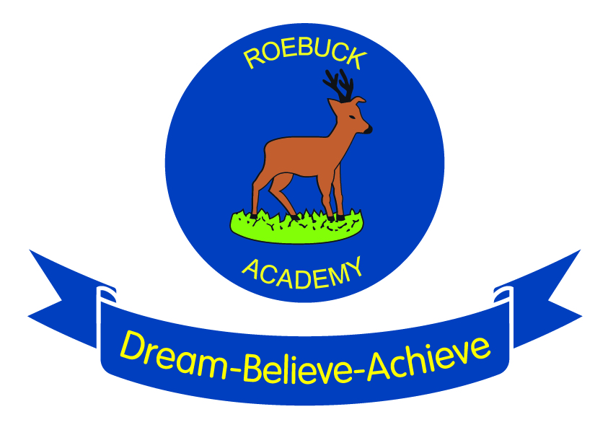

Writing at Roebuck

Writing teaching and philosophy at Roebuck Academy
Philosophy and Aims
We expect our children to receive a high quality writing education that ensures they are fluent, confident and competent writers across a range of genres.
Expectations
We are committed to closing the attainment gap and ensuring that no child is left behind. As such our expectation is that all children will make expected progress and more than expected progress where they have the capacity to do so.
Writing in class
Writing is embedded across the curriculum. Writing skills such as grammar, punctuation and spelling, as well as the composition of different text types, are taught in daily English lessons.
Writing should be planned; taking into account a clear sequence of learning from creating interest through engaging stimulus, to reading, then speaking and listening activities such as hot-seating and role-play before planning and writing which will include editing and improving.
Teachers are encouraged to make meaningful and relevant links across the curriculum when planning their writing.
Working walls in classrooms should support children’s independent writing and evolve as the unit of work unfolds; they are not intended to be finished displays. They should exemplify the writing process.

