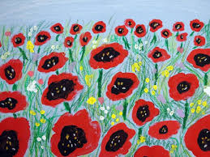
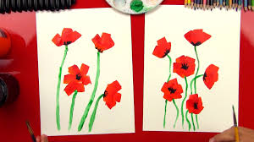

Half-Term Topic Homework World Wars– Year 3
Remember to make sure that you read at least Ten times during half-term! Choose one of these activities as well to do this half term. You can be as creative as possible.
Make a 3d Poppy of your own. Choose your own way to make this. | Write about someone who is your hero. | Draw or paint a picture of someone important in WW1 or WW2 (e.g. a soldier, nurse etc.)
Paint or draw a picture of a Poppy. | Make your own Anderson model shelter | Write some facts about WW1 or WW2.


