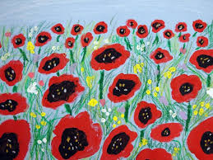
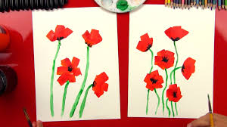

Half-Term Topic Homework World Wars– Year 6
Remember to make sure that you read at least Five times during half-term! Choose one of these activities as well to do this half term. You can be as creative as possible.
Create a piece of Poppy art or sculpture | Research and record information  about Jack Cornwell  http://www.bbc.co.uk/schools/0/ww1/25356042 | Research key facts about WW1 and WW2:  Why did the wars start?  When did they start and how long did they last?  Which countries fought on which side?
Research: what was life like in the trenches in WW1?  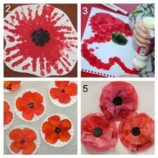 | Make your own trench shoebox  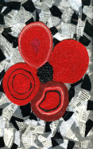  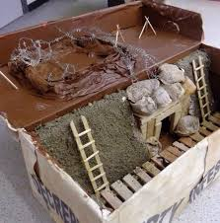 | 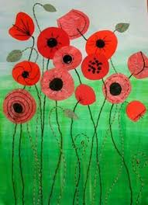  Print off a World map and show on it which countries fought in WW1 or WW2. Use a key to signal which side they were on.

