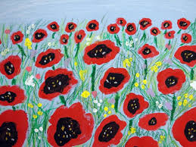
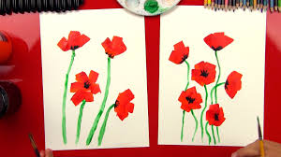

Half-Term Topic Homework WW1– Year 2.
Remember to make sure that you read at least Five times during half-term! Choose one of these activities as well to do this half term. You can be as creative as possible.
Make a 3d Poppy of your own. Choose your own way to make this. | Write about someone who is your hero. | Draw or paint a picture of someone important in WW1. (eg a soldier, nurse etc)
Write a diary. What was it like to be a nurse or solider in the war? | Write a poem about poppies and what they remind us of each year. | Write some facts about WW1.  Create a facts poster


