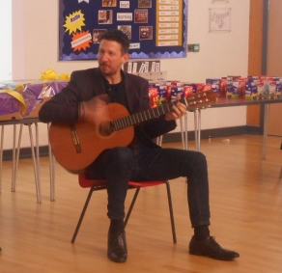
Wow! What an amazing Dream Catcher assembly we had today! We were joined by Ben Smith who is a professional musician who comes from Hitchin. He played us some songs and we were all tapping our feet and singing along. Ben learnt to play the guitar at the age of 6 and always dreamed of being a professional musician. After 12 years of music lessons, and attending music-college, he turned semi-professional and now plays in many different bands around the country entertaining lots of people. A really good example of how perseverance and determination can help you to reach your goals.
Freddie in Year 6 also got up and sang a song with Ben. It was a very impressive performance and we certainly think we have a star in the making! You can see more performances by Ben by looking at his website http://www.bennyguitarsmith.com/

