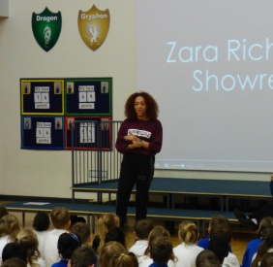
Last Thursday, we were really lucky to be joined by Zara Richards - a dance teacher from Stevenage who is also a professional dancer. Jayden in Year 3 recommended Zara as he goes to her street dancing class every week. Zara began by showing us her show reel which showed her appearances on Britain's Got Talent as well as numerous appearances on TV adverts and music videos supporting famous artists such as Tinie Tempah and Cher Lloyd.
After asking her many questions, we discovered that Zara had always wanted to be a dancer from the young age of 5 and that with hard work and determination she had successfully managed to make her dreams come true. She works long hours and shows a real commitment to her profession.
Many children were left feeling really inspired. Grace in Year 5 said, "She's inspired me by not giving up so I'm not going to give up on my dream either." At Roebuck we all tell our children to dream, believe and then you will achieve! Thank you Zara for sharing such an excellent real-life example.

