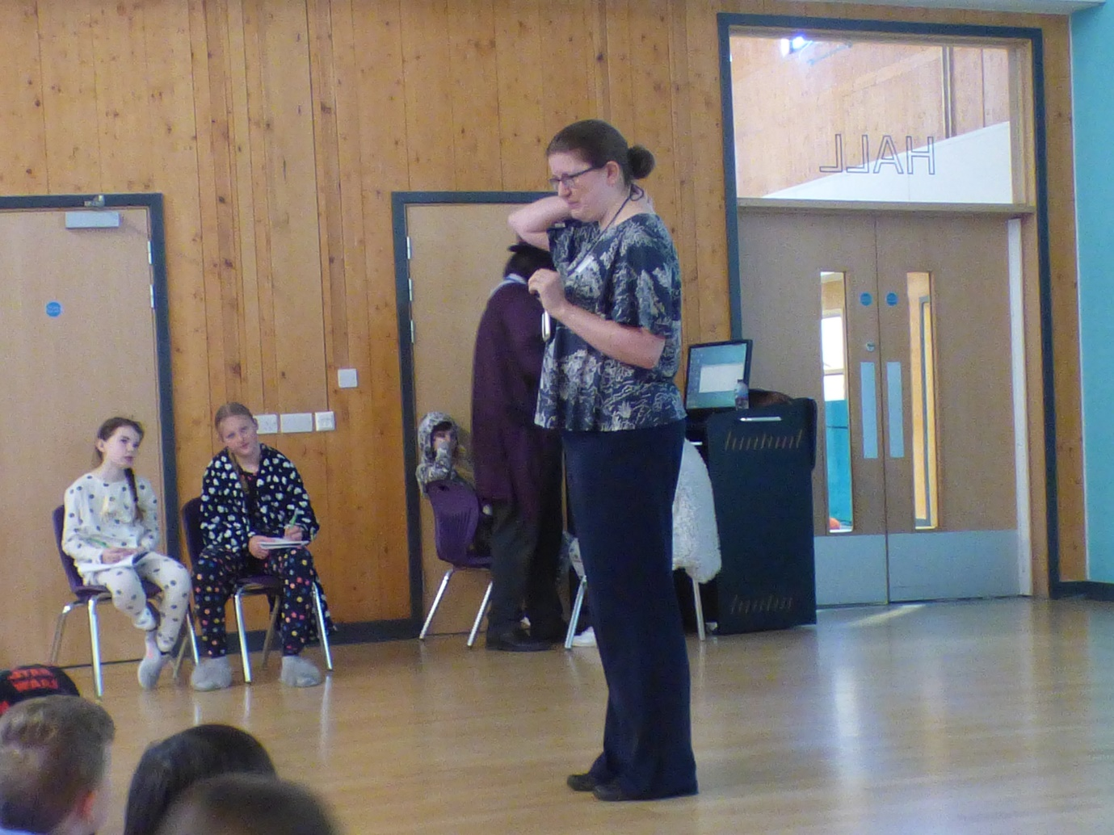

Last week, Katherine Dunston came to Roebuck and delivered a Dream catcher assembly. Katherine works at Knebworth House and she talked to the children about some of the work that she does there. Currently she is focussing her time on helping to develop an APP that will allow visitors, especially children, to understand more about the Watchman's Tower at the house, which is currently being renovated. Having first dreamt of being an astronaut when she was young, Katherine became a teacher in a Primary School, teaching Year 1 and 2 pupils and then she moved onto working at Knebworth House. Her working day varies, as she could be showing round groups of visitors, planning out work experience placements for students and even dressing up in costumes for classes of children to bring the history of the house to life.
On finishing the assembly, Katherine gave the children a nugget of wisdom, which was to enjoy trying different things, especially when you are young.

