Friday 14th February 2020
Year 5 Smartie Day
We began our day by estimating how many smarties were in our tube. Then, we opened them and sorted our smarties into colours, discussing the most, least and colours which had the same numbers. Next, we sorted our colours into a pictogram. We then made statements such as, ‘If one smartie stands for 3, I actually have 15 brown smarties.’
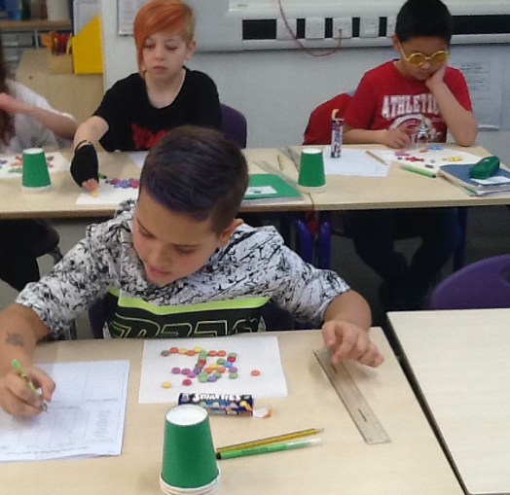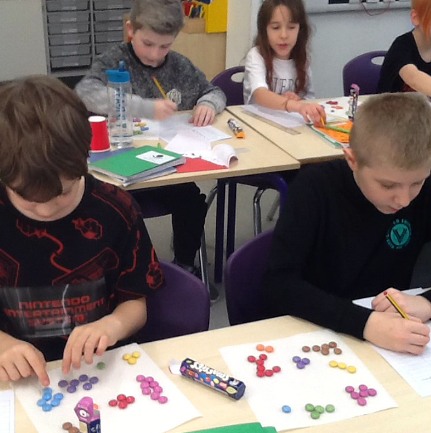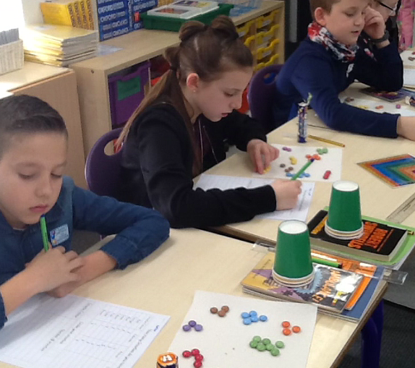
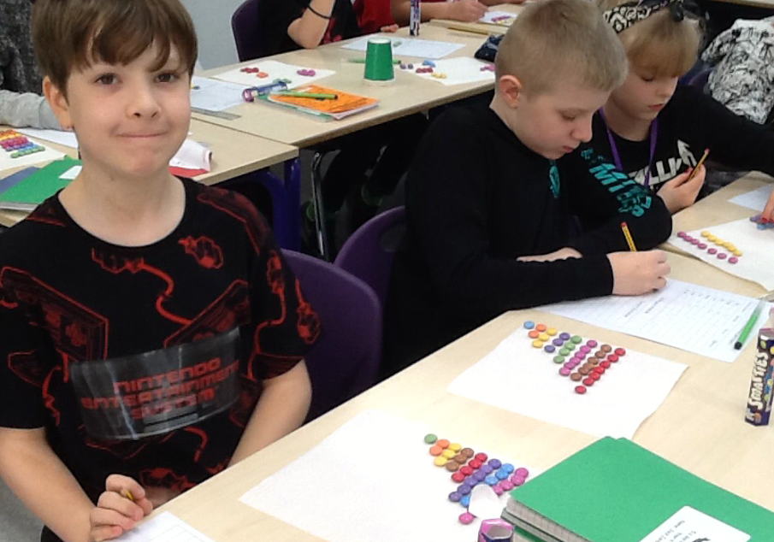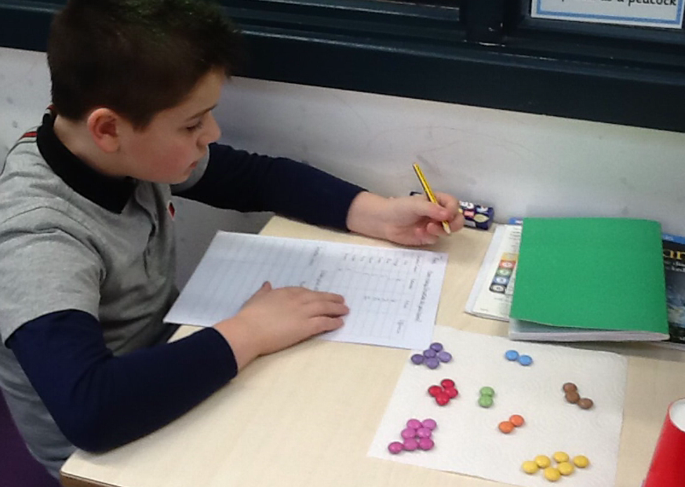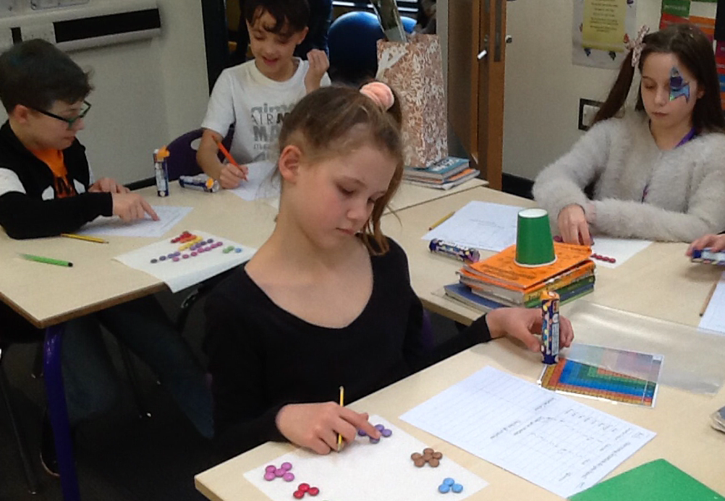
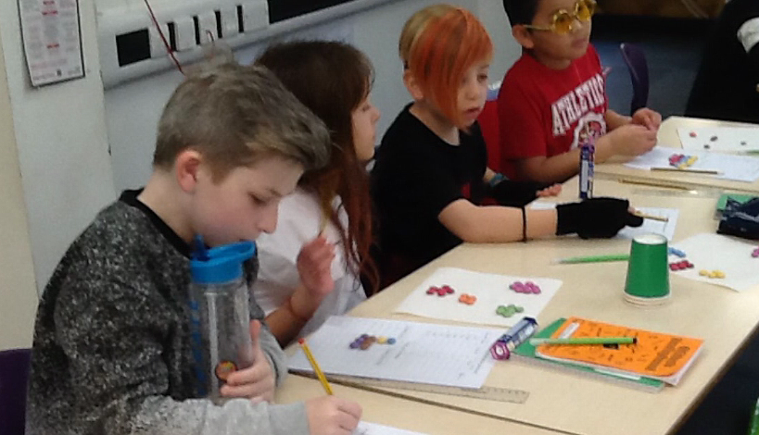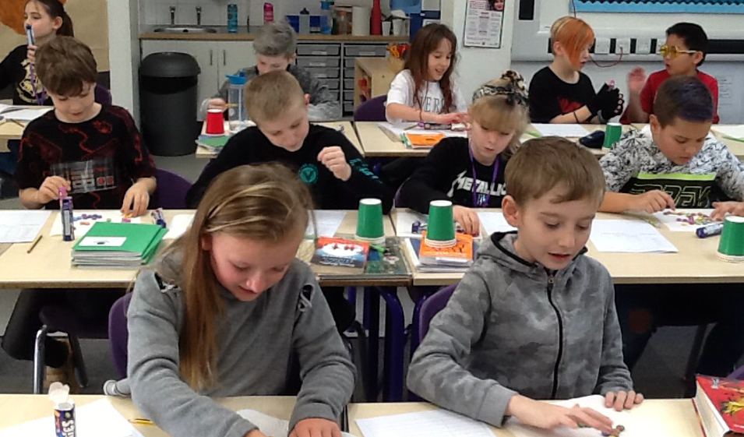
Next we learned about mean, median, mode and range and found the answers for our set of smarties. We used this rhyme to help us:
Hey diddle diddle, the median’s the middle,
You add then divide for the mean.
The mode is the one that you see the most,
And the range is the difference between.
Later on in the lesson, we revised our understanding of fractions by representing each colour as a fraction. We then simplified these fractions if it was possible. Next, we practised adding and subtracting fractions by answering questions such as, “What fraction of smarties are NOT blue? How many smarties are green or yellow?”
We had a little introduction to ratio. After learning how to write two colours as a ratio, we then posed the question, “If the ratio of blue to orange smarties is 2:4, how many of each colour would there be in 3 packs?” We used multiplication to find out the answers.
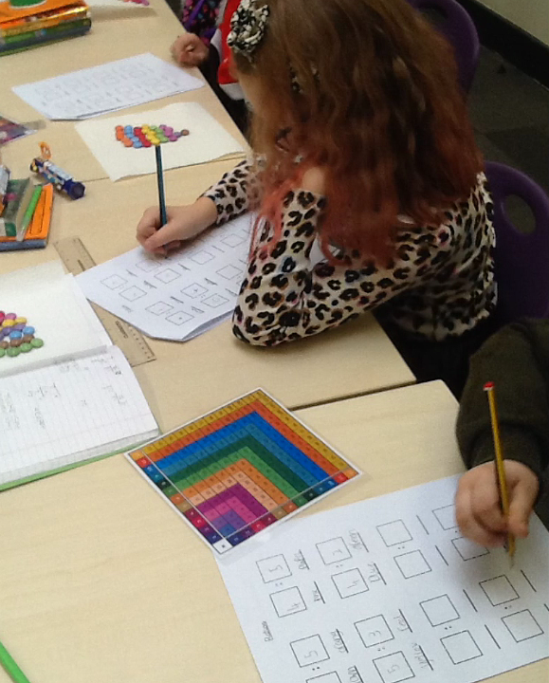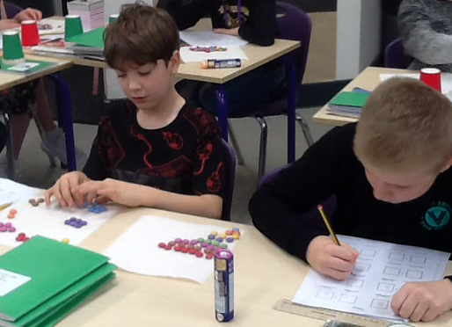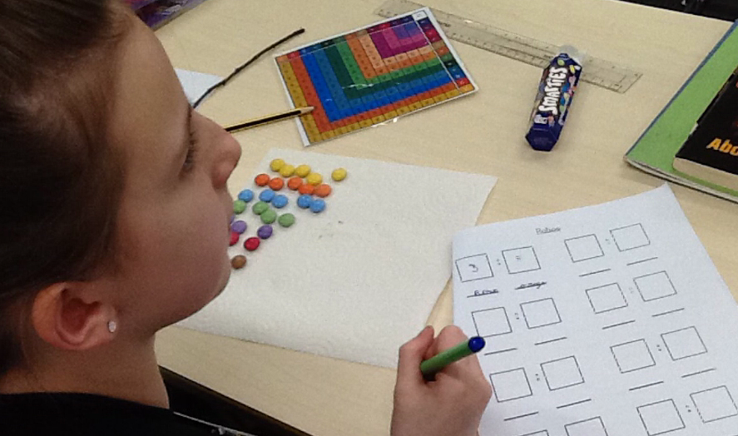
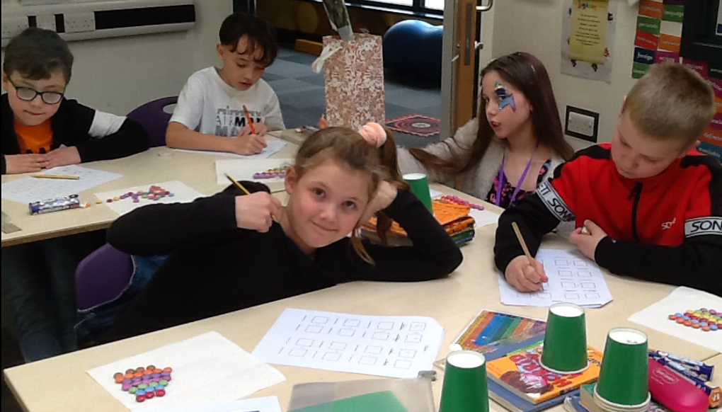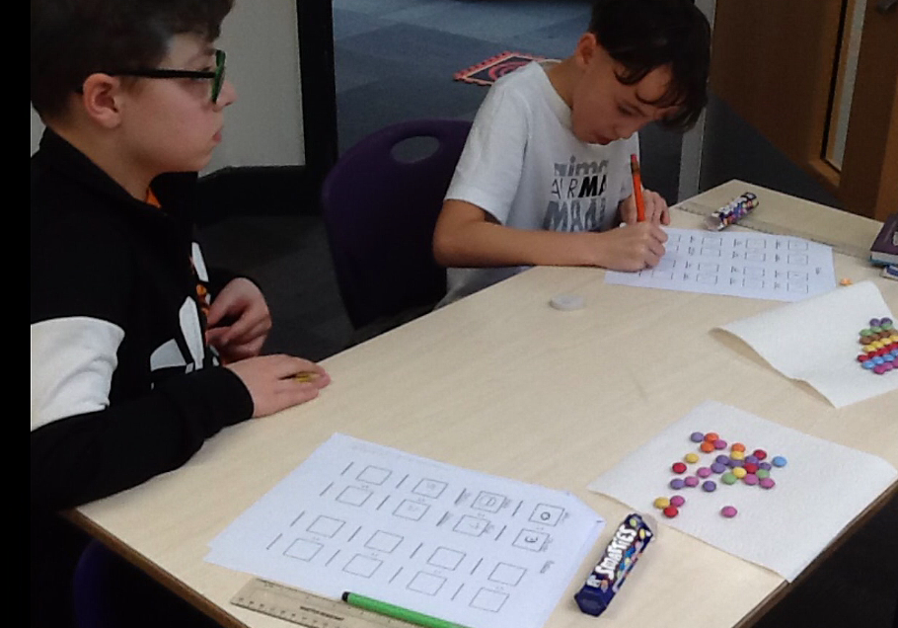
Some of us even had time to use our smarties to show it was Valentine’s Day!
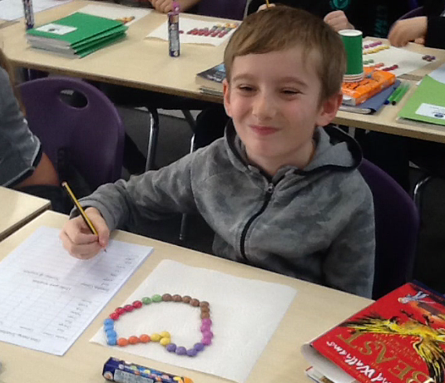
In the afternoon, we had fun trying to beat our own scores and times on TTRockstars!


