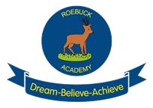
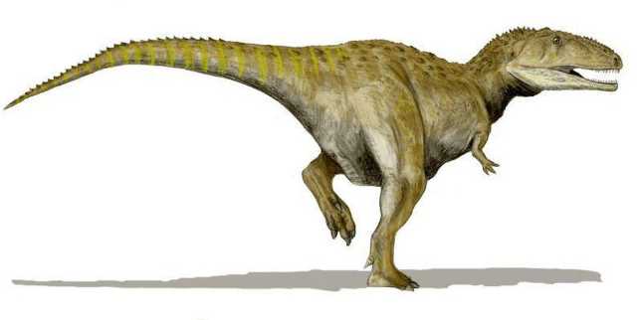
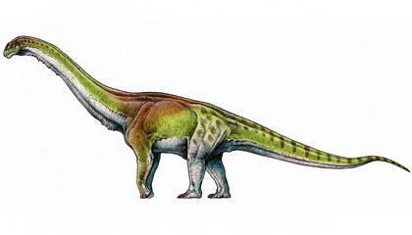

Topic Work - Pirates and Dinosaurs- Reception
Make a treasure map and label it. | Write a message in a bottle.
What is your favourite dinosaur and why? (Write about it) | Make a junk model dinosaur.
Complete one activity per week. You can be as creative as you like and share your work on Tapestry.



