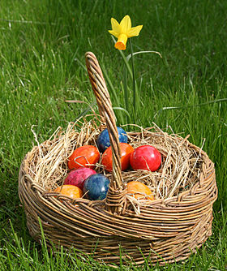


Easter Topic Homework - Reception.
Remember to do some reading over the holidays! Can you build a den to read in or find a different place to read a book? You can do as many of these activities as you want to do. You can be as creative as possible.
Scavenger hunt in the garden.  (You can search for chocolate eggs!)   | Draw a picture of what you see outside your window. | Paint the fence.  (Use a brush, bowl of water and paint the fence or floor)
Easter Themed Craft. | How is Easter celebrated in a different country? | Can you lead your family in a short exercise circuit?


