Tuesday 16th June 2020
LO: To explore a character in detail, using evidence from the film to support our ideas.

Mild
Inside the ballerina, write words to describe her appearance and how she moves.
Outside the ballerina, write two questions about what you want to ask her.
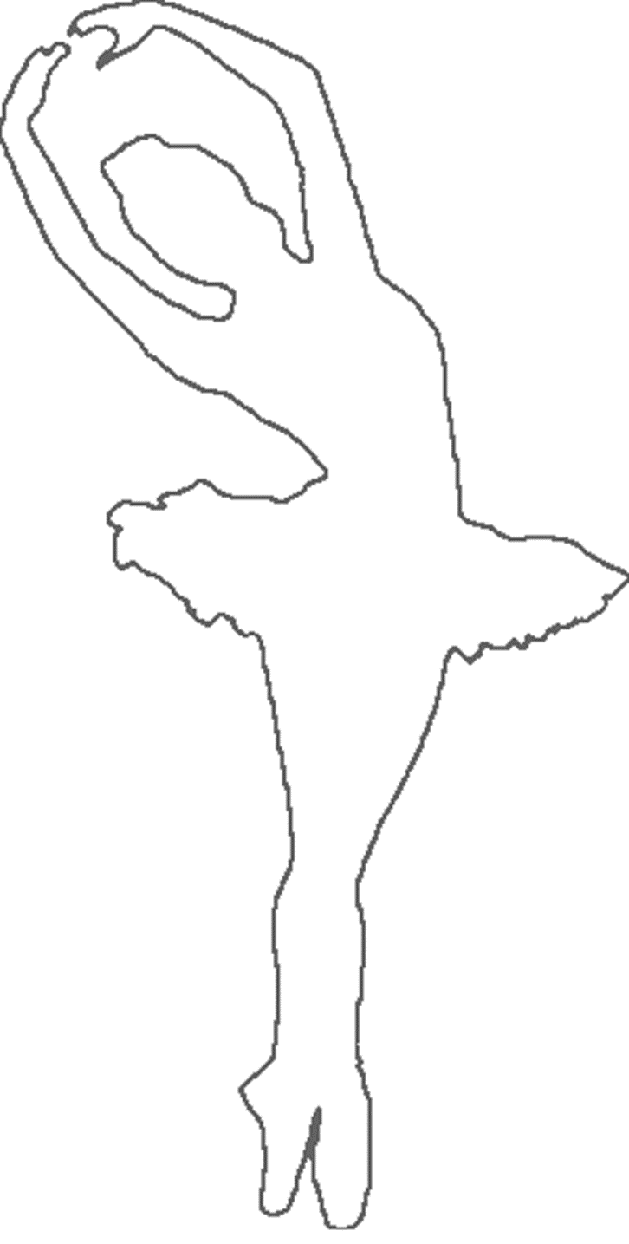

Spicy/Hot
Outside the ballerina, write in how the ballerina is feeling throughout the film. Using evidence from the film, use because to back up your ideas.


Inside the ballerina, write possible questions that you would want to ask her or what’s going to happen next.


