
Wednesday 17th June 2020
LO: To write ‘3ed’ sentences
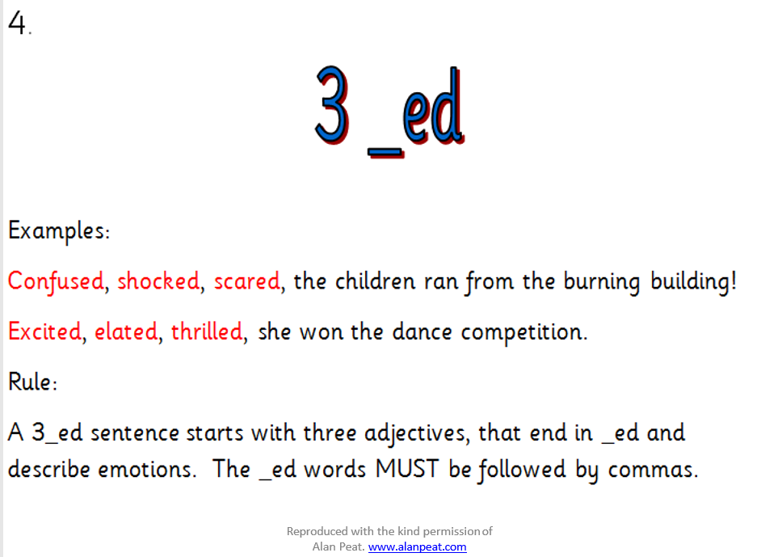
Mild, Spicy and Hot

Surprised, excited, worried, the ballerina stepped off the wooden platform.
_________________, ___________________, ____________________, the balloons floated higher and higher.
________________________________________________________________________________________________________________________________________________________________________________________________________________________________________________________________________________________________________________________________________________________________________________________________________________________________________________________________________________________________________________________

Wednesday 17th June 2020
LO: To write ‘3ed’ sentences and ‘2 pairs’ sentences
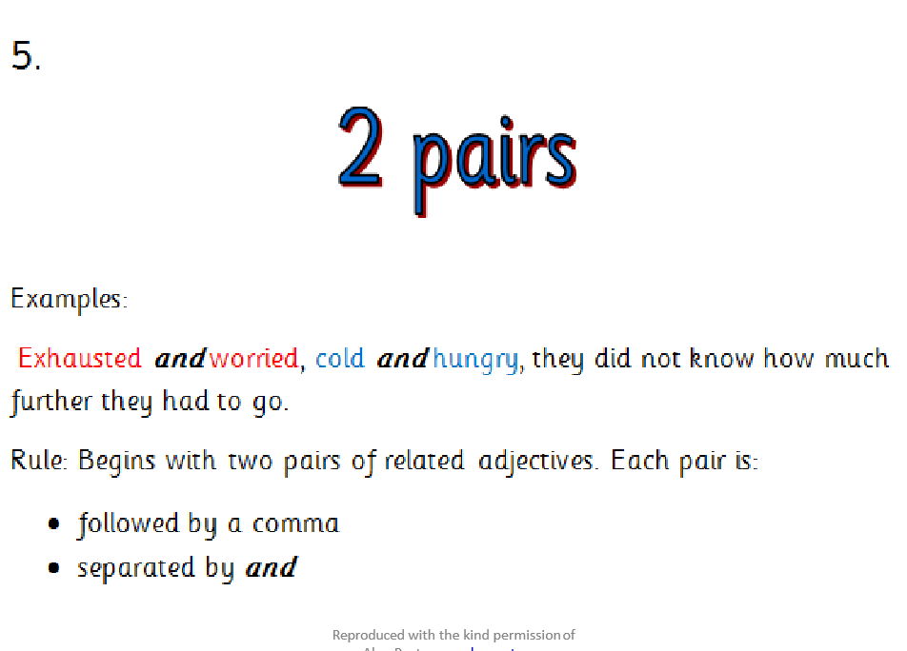
Spicy and Hot

Excited and elated, careful and brave, the dancer tiptoed down the steps. ________________________________________________________________________________________________________________________________________________________________________________________________________________________________________________________________________________________________________________________________________________________________________________________________________________________________________________________________________________________________________________________


Wednesday 17th June 2020
LO: To write ‘3ed’ sentences , ‘2 pairs’ sentences and ‘verb, person’ sentences
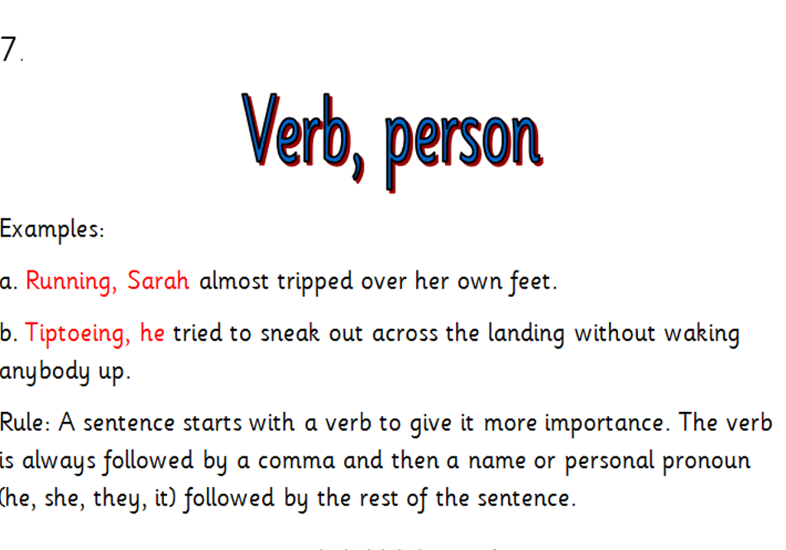
Hot

Sobbing, she felt her heart shatter as the balloons froze in the cold air.
________________________________________________________________________________________________________________________________________________________________________________________________________________________________________________________________________________________________________________________________________________________________________________________________________________________________________________________________________________________________

