
Monday 15th June 2020
Understanding Fractions
Page 1

https://drive.google.com/file/d/1q5U4K0U0-ESZ1cdRHUQqcgoC0ttezT6M/view
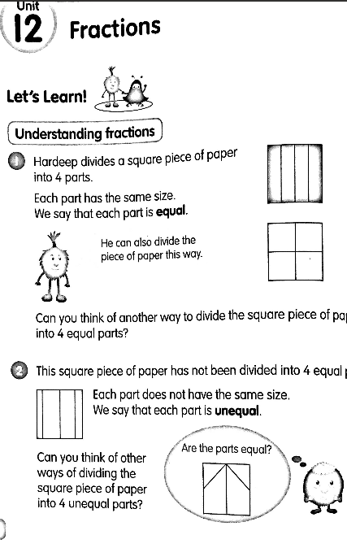


Monday 15th June 2020
Understanding Fractions
Page 2

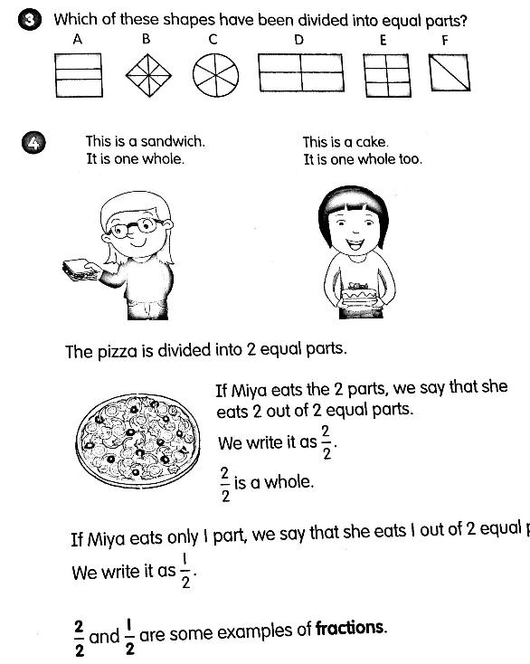


Monday 15th June 2020
Understanding Fractions
Page 4

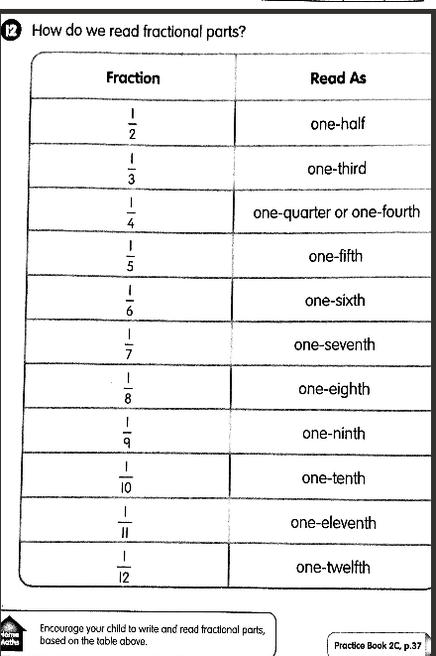

Monday 15th June 2020
Understanding Fractions
Page 3

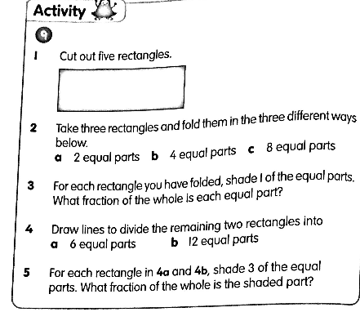




Monday 15th June 2020
Understanding Fractions
Page 5
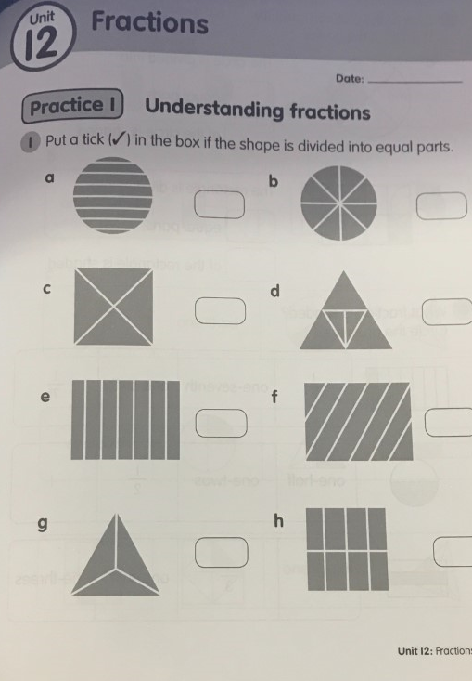

Monday 15th June 2020
Understanding Fractions
Page 6
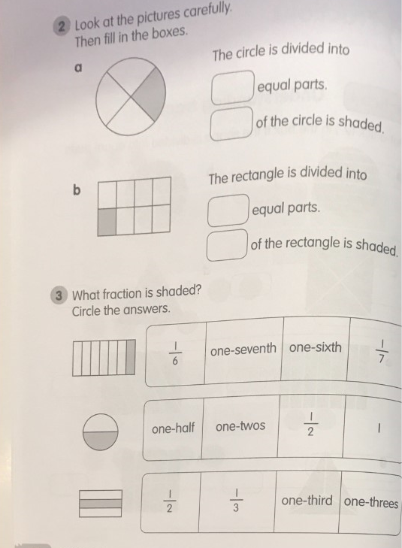

Monday 15th June 2020
Understanding Fractions
Page 7

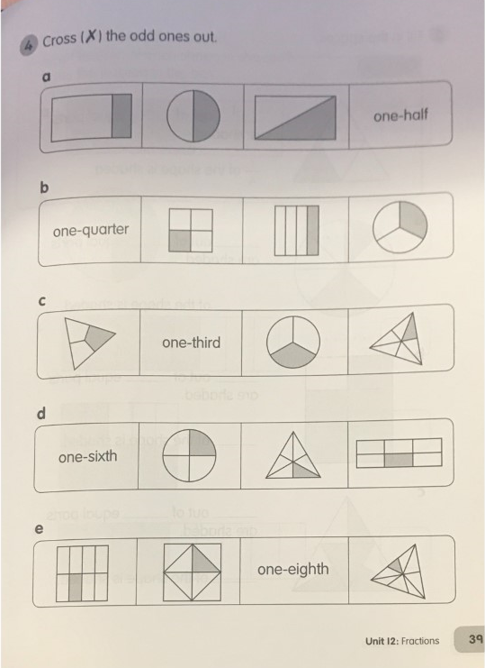

Monday 15th June 2020
Understanding Fractions
Page 8
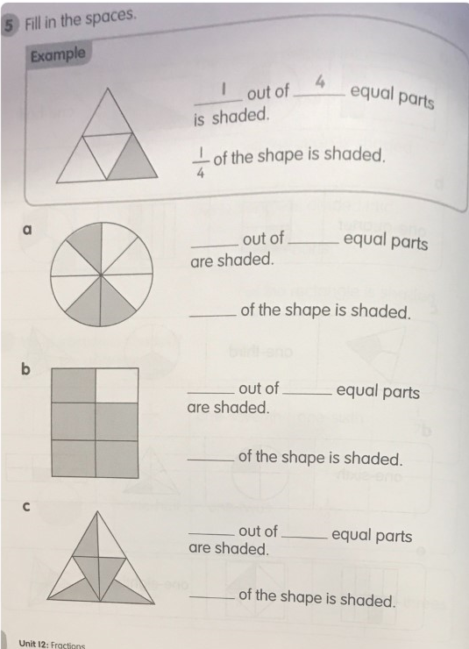


Monday 15th June 2020
Understanding Fractions
Page 9
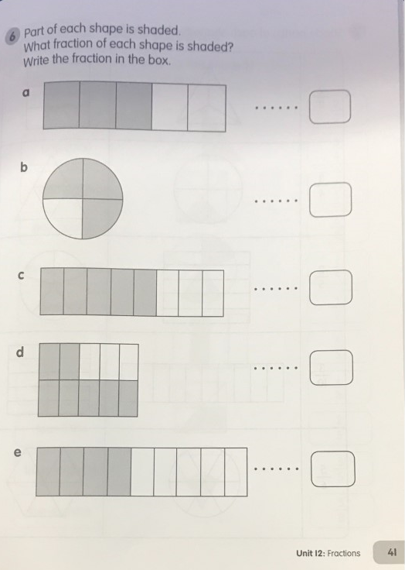

Tuesday 16th June
Understanding Fractions
Page 1
https://drive.google.com/file/d/1dQE-PB6mRz3C9uOWwNhpj4b4VOVm0xxP/view
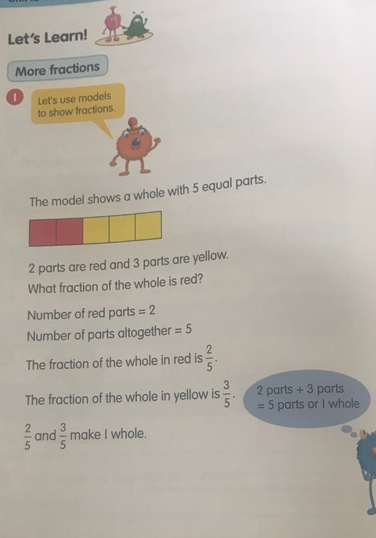

Tuesday 16th June
Understanding Fractions
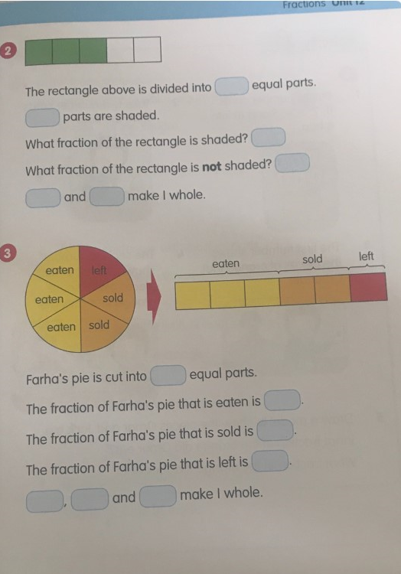
Page 2

Tuesday 16th June
Understanding Fractions
Page 3
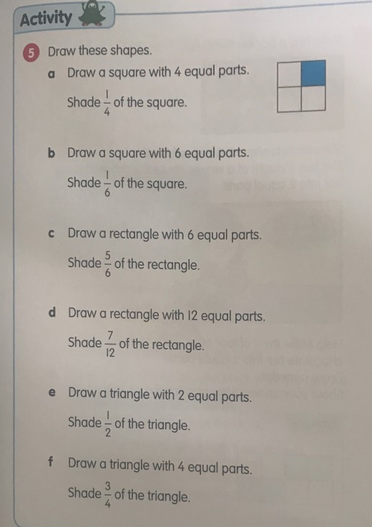


Tuesday 16th June
Understanding Fractions
Page 4
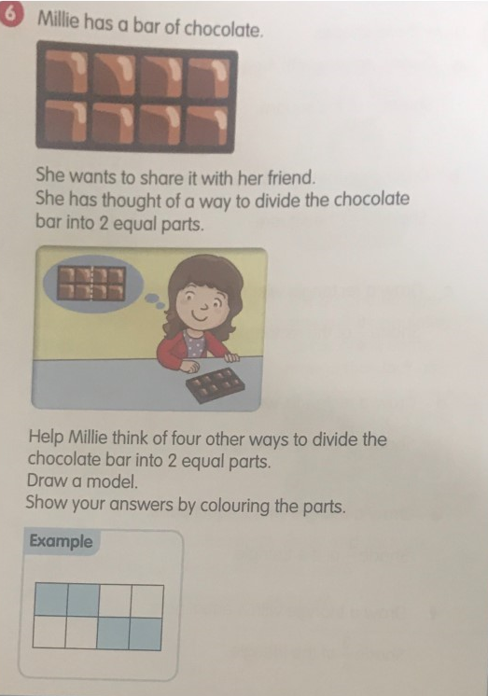


Tuesday 16th June
Understanding Fractions
Page 5
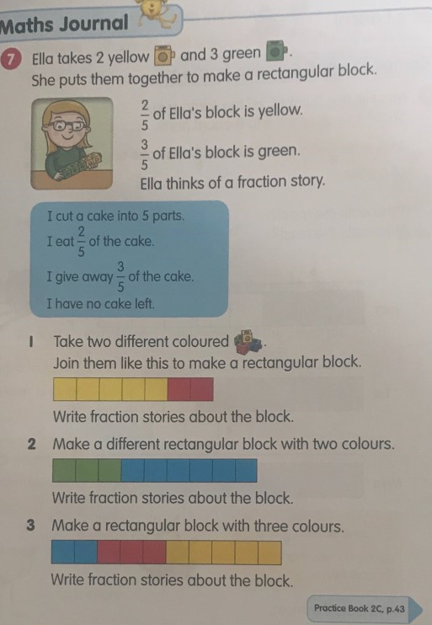


Tuesday 16th June
Understanding Fractions
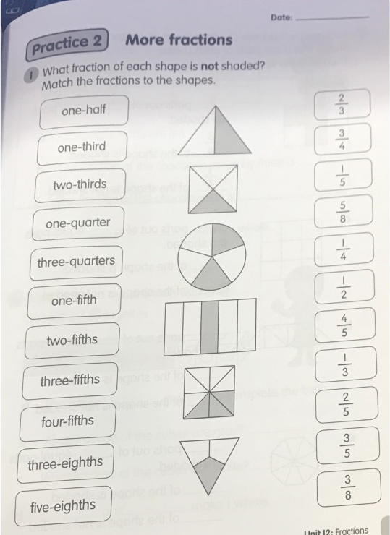
Page 6


Tuesday 16th June
Understanding Fractions
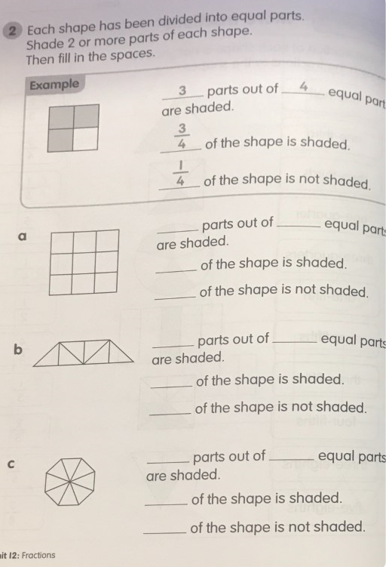
Page 7


Tuesday 16th June
Understanding Fractions
Page 8
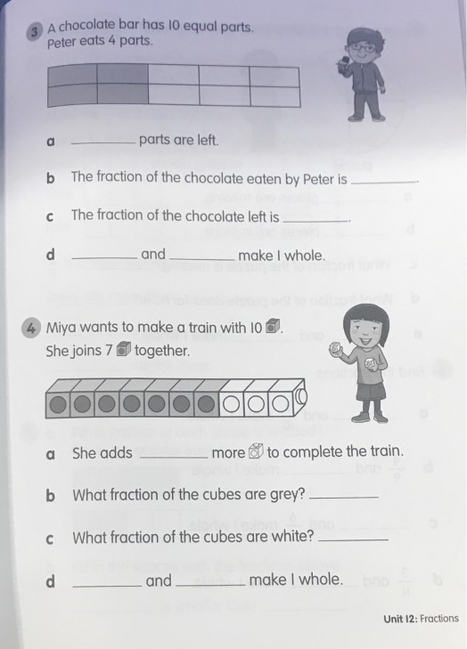

Tuesday 16th June
Understanding Fractions
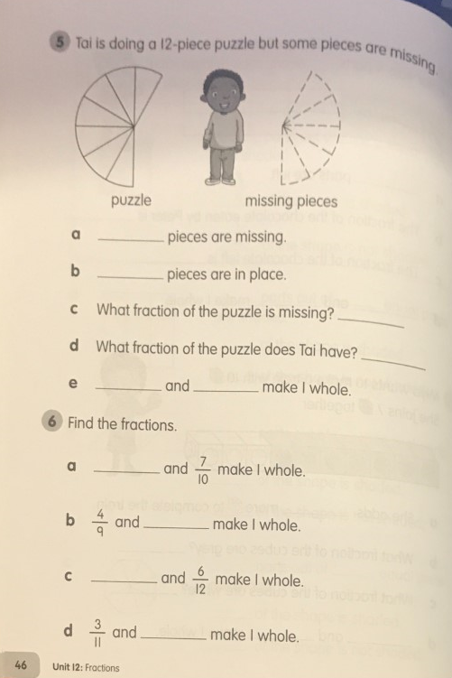
Page 9

Wednesday 17th June
Comparing and ordering fractions
Page 1
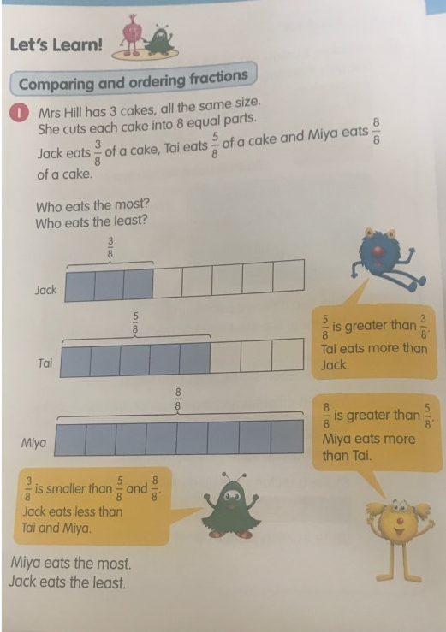
https://drive.google.com/file/d/11HzP269_EcpdWx4HQ_LAAiMKpVJSXIXA/view

Wednesday 17th June
Comparing and ordering fractions
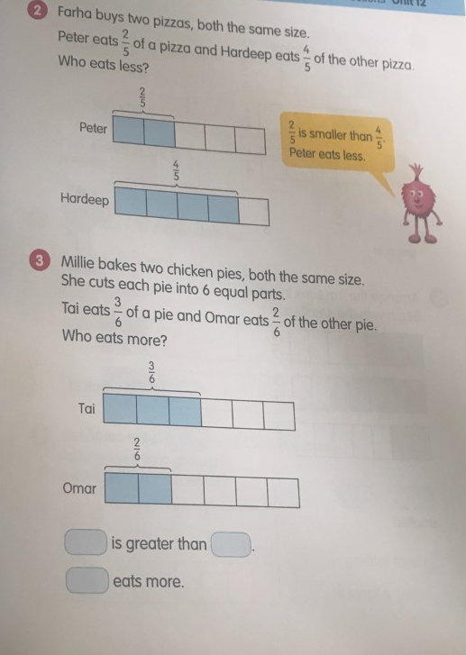
Page 2

Wednesday 17th June
Comparing and ordering fractions
Page 3
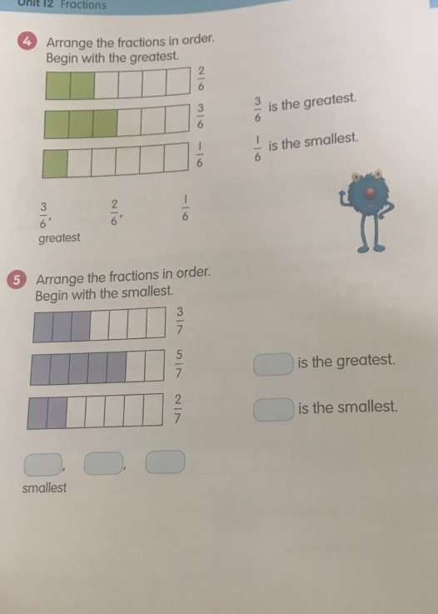

Wednesday 17th June
Comparing and ordering fractions
Page 4
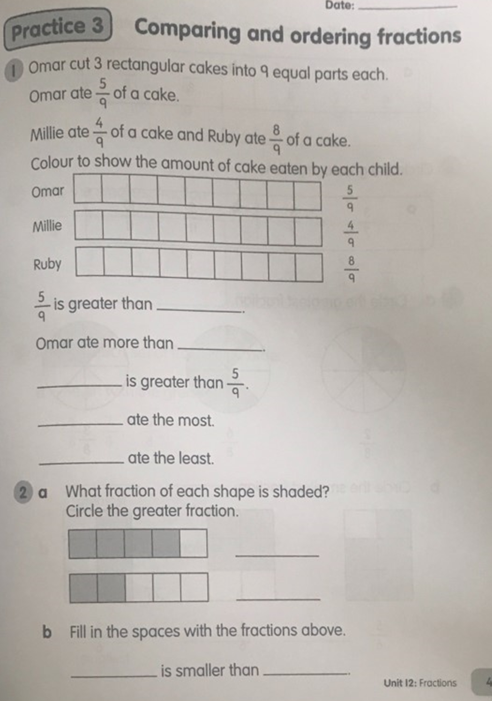


Wednesday 17th June
Comparing and ordering fractions
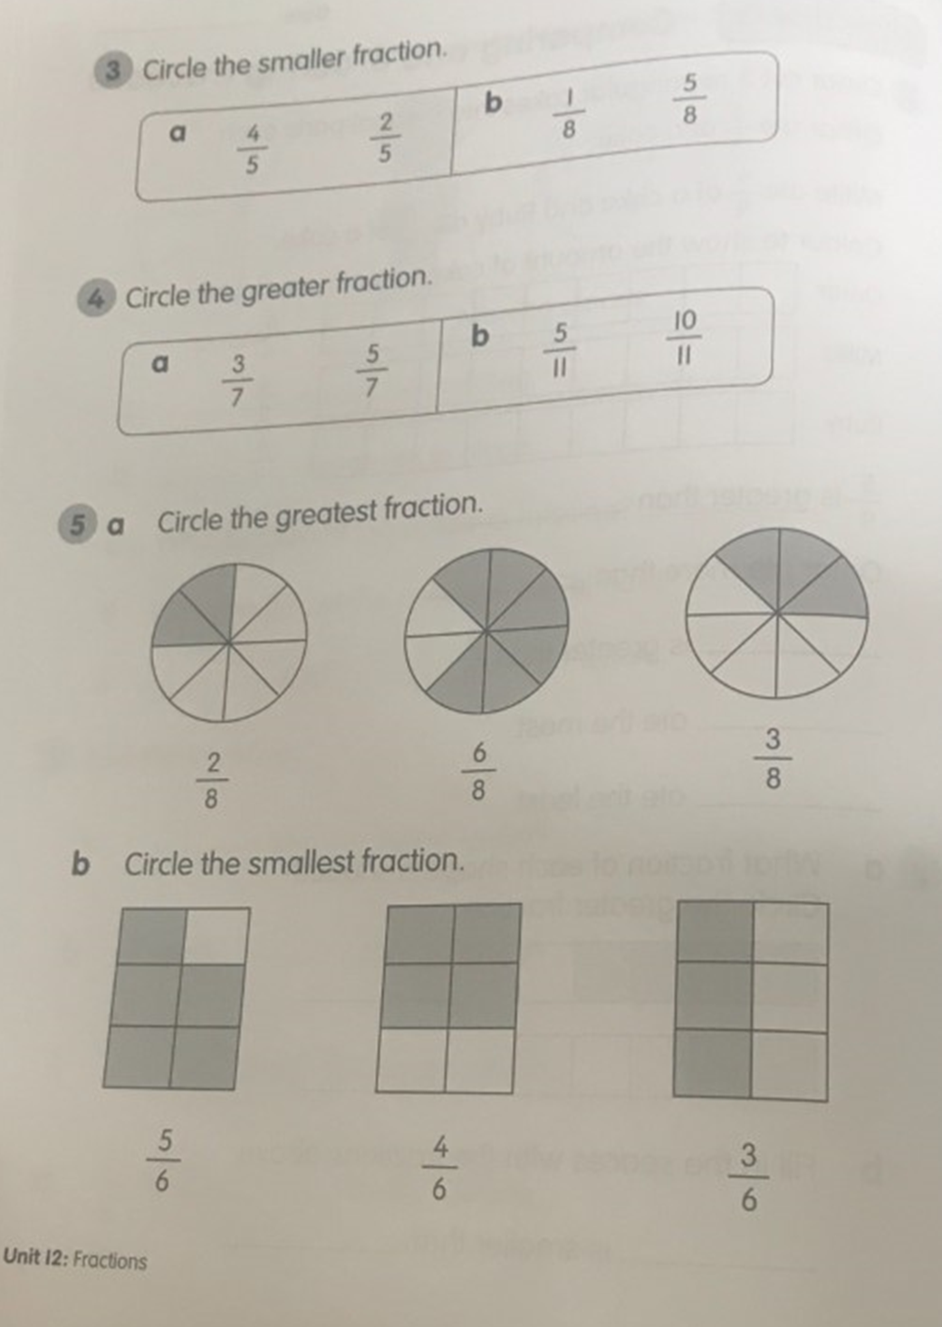
Page 5

Wednesday 17th June
Comparing and ordering fractions
Page 6
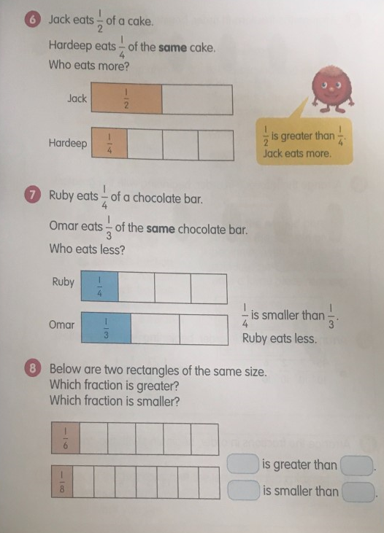
https://drive.google.com/file/d/1uDQ3npzFnM3cqu5viljlO-4mq4SoYAE1/view


Wednesday 17th June
Comparing and ordering fractions
Page 7
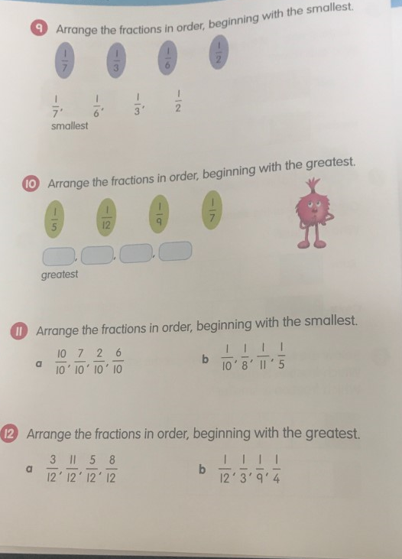

Wednesday 17th June
Comparing and ordering fractions
Page 8
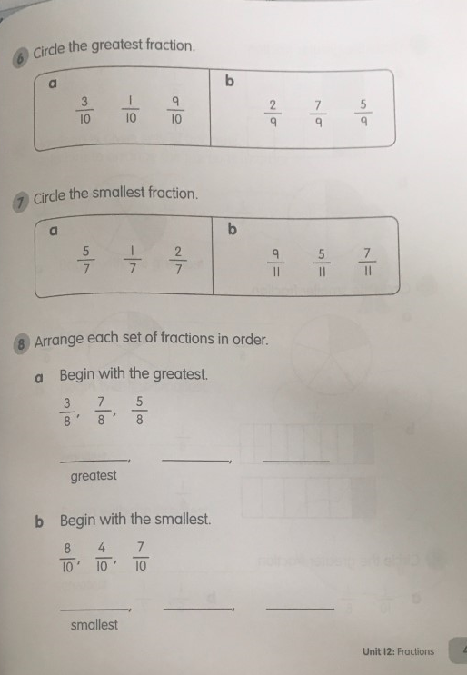


Wednesday 17th June
Comparing and ordering fractions
Page 9
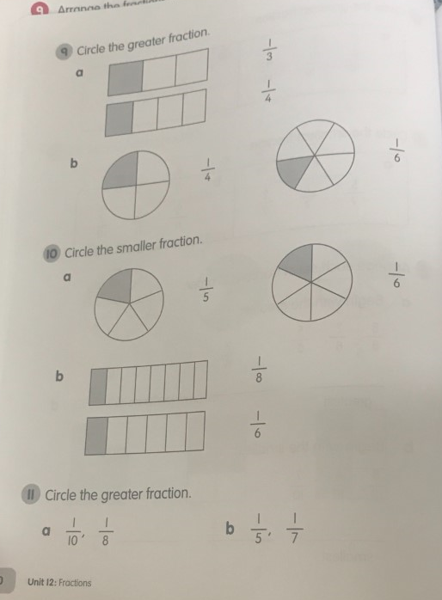

Wednesday 17th June
Comparing and ordering fractions
Page 10
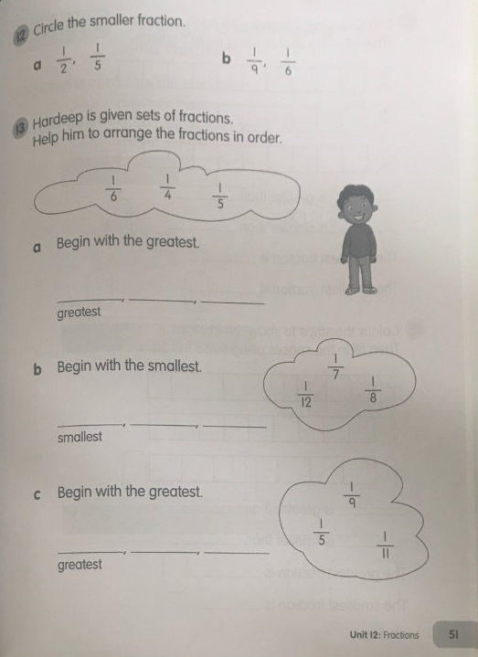

Wednesday 17th June
Comparing and ordering fractions
Page 11
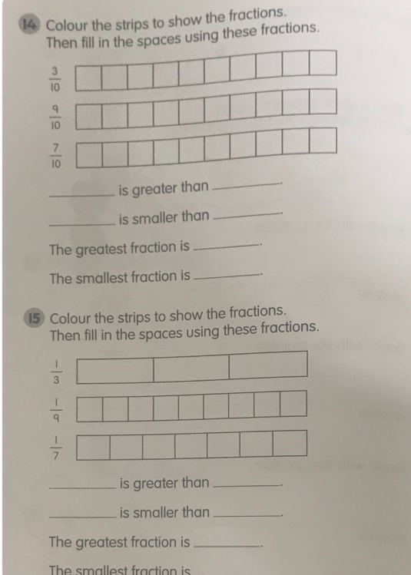


Thursday 18th June
Adding and Subtracting Fractions
Page 1

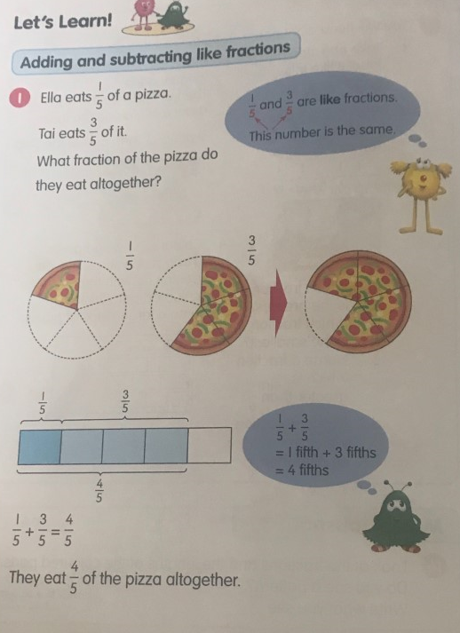
https://drive.google.com/file/d/1zIJ2D-cAIvtnAR6LI6Hc9w3zktbUGm-D/view

Thursday 18th June
Adding and Subtracting Fractions
Page 2

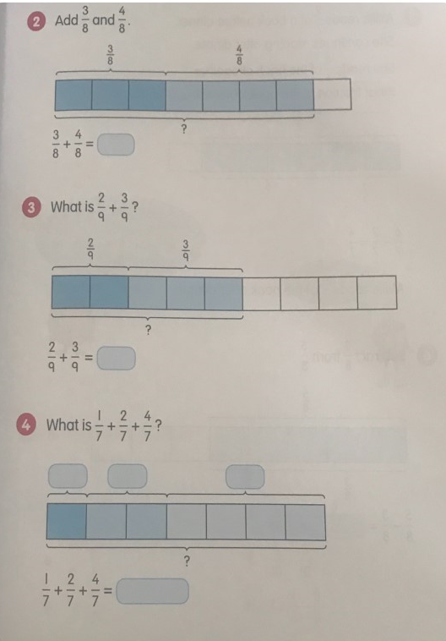


Thursday 18th June
Adding and Subtracting Fractions
Page 3
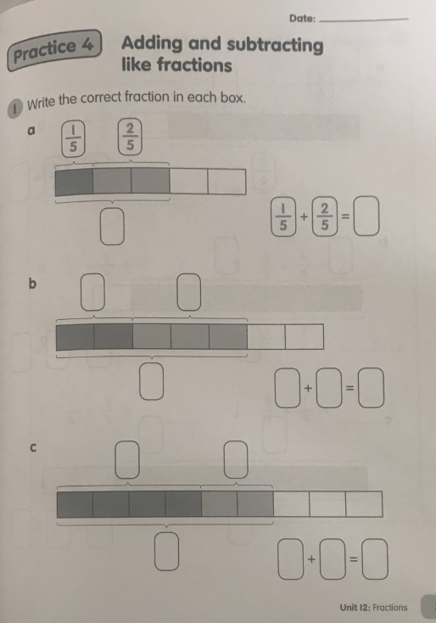

Thursday 18th June
Adding and Subtracting Fractions
Page 4
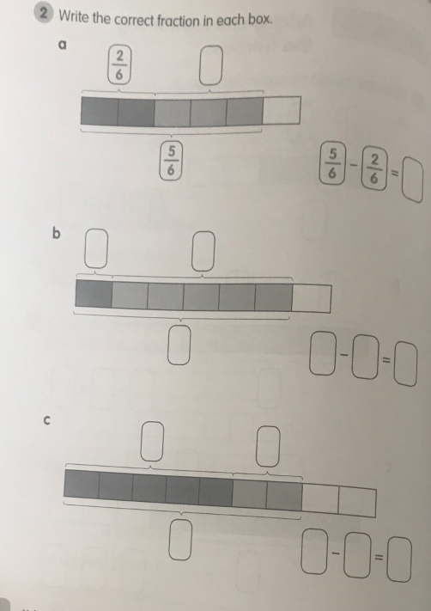


Thursday 18th June
Adding and Subtracting Fractions
Page 5
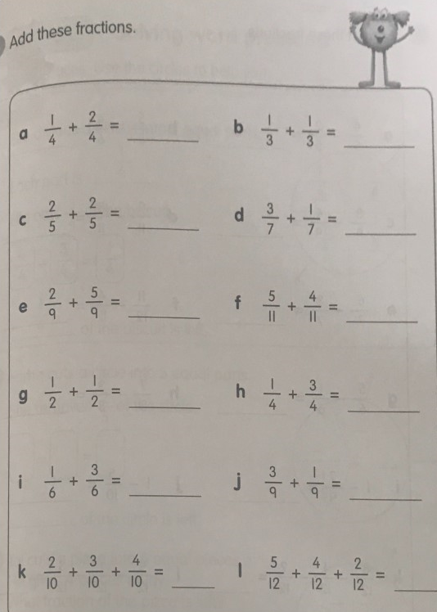

Thursday 18th June
Adding and Subtracting Fractions
Page 6
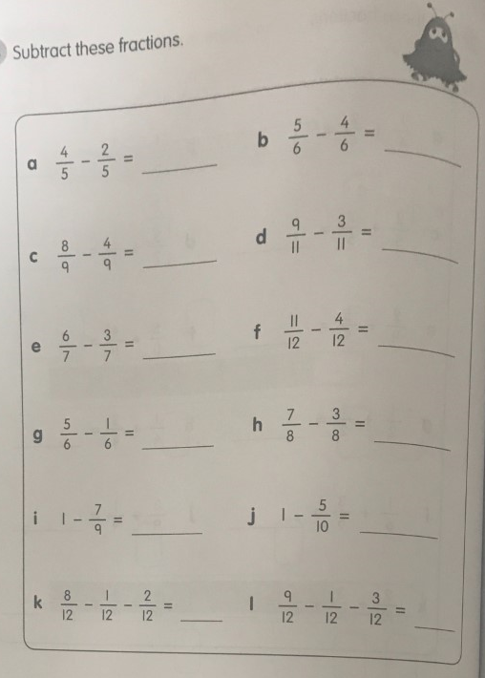

Thursday 18th June
Adding and Subtracting Fractions
Page 7
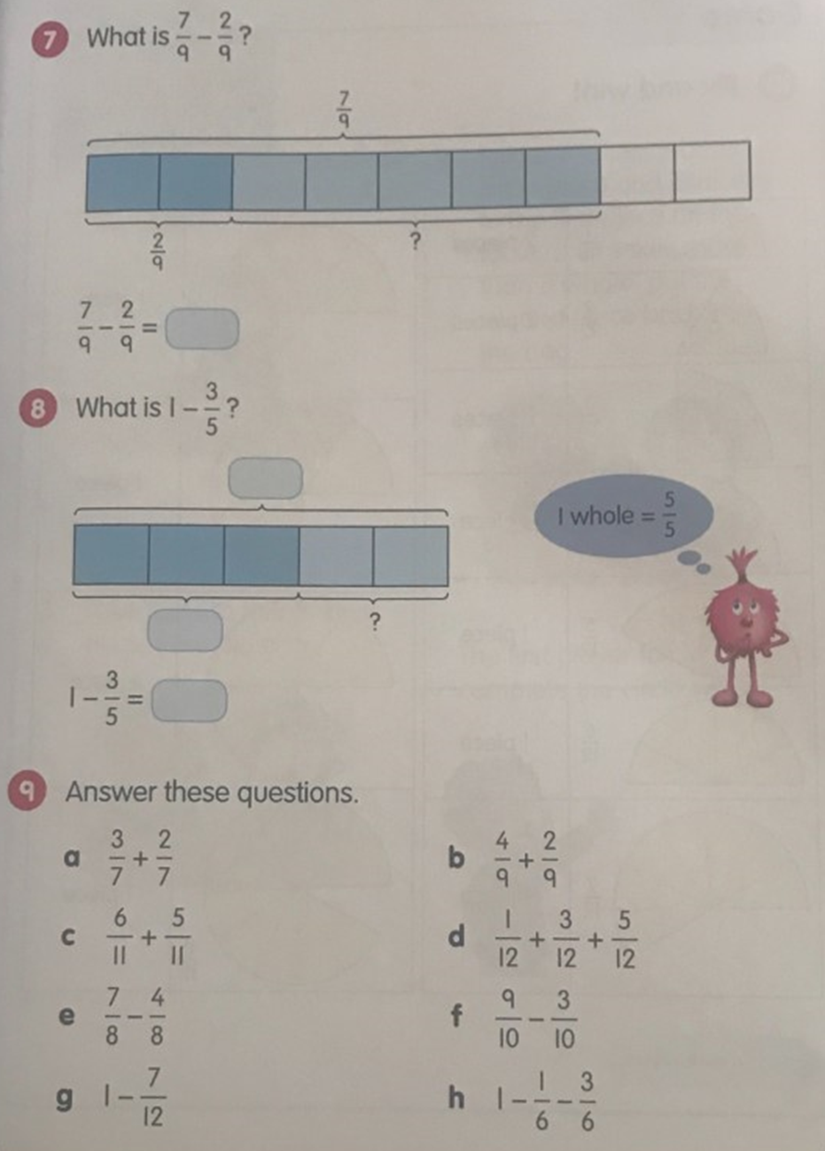


Friday 19th June 2020
Word problems with fractions
Page 1

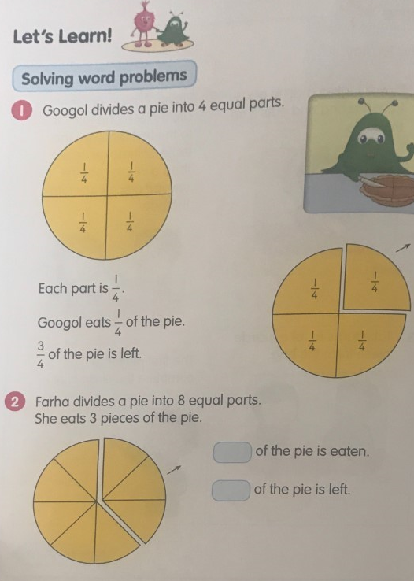
https://drive.google.com/file/d/1GaUb6yFeDhVGlZPQlOC4JAynZeEopPgW/view

Friday 19th June 2020
Word problems with fractions
Page 2
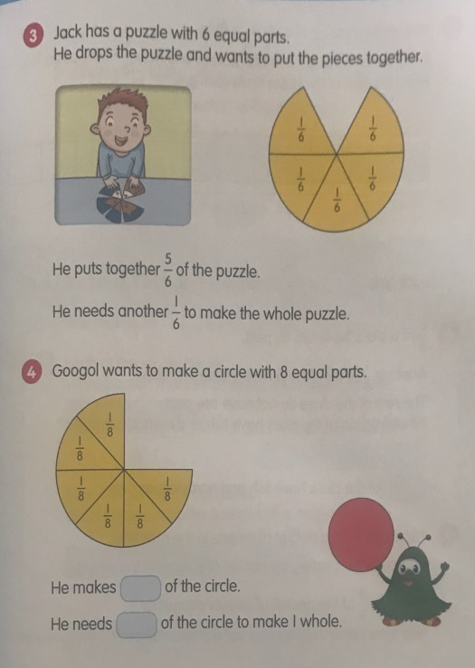

Friday 19th June 2020
Word problems with fractions
Page 3
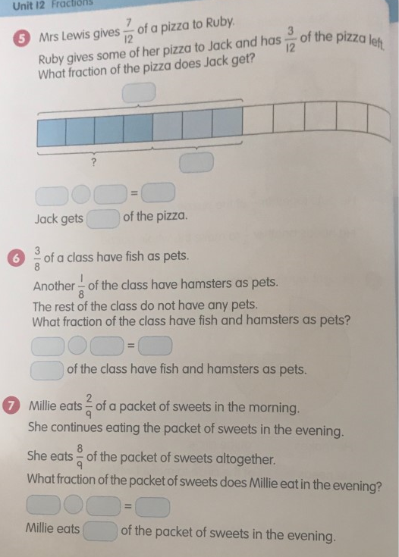

Friday 19th June 2020
Word problems with fractions
Page 4
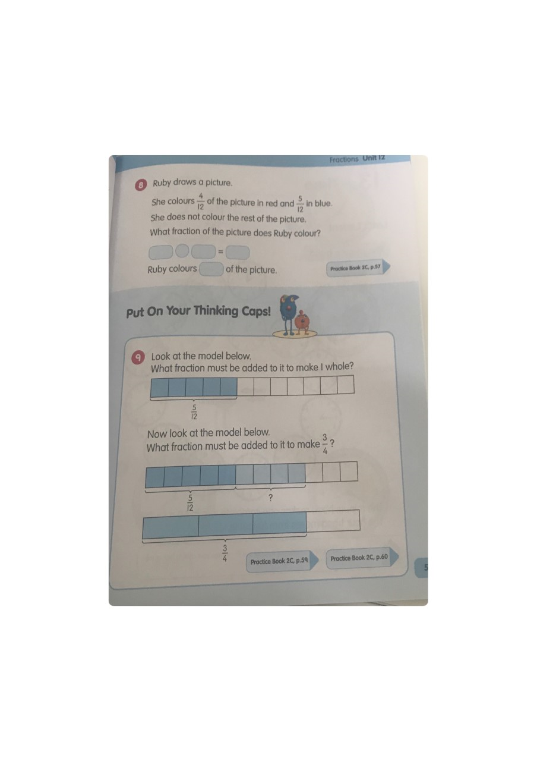

Friday 19th June 2020
Word problems with fractions
Page 5

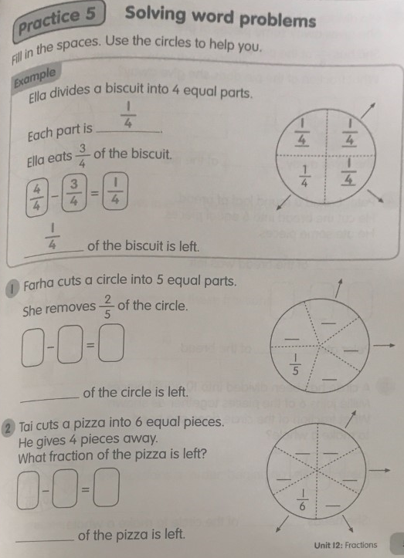

Friday 19th June 2020
Word problems with fractions
Page 6

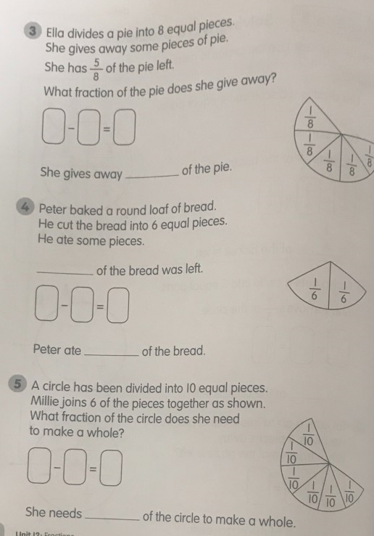

Friday 19th June 2020
Word problems with fractions
Page 6

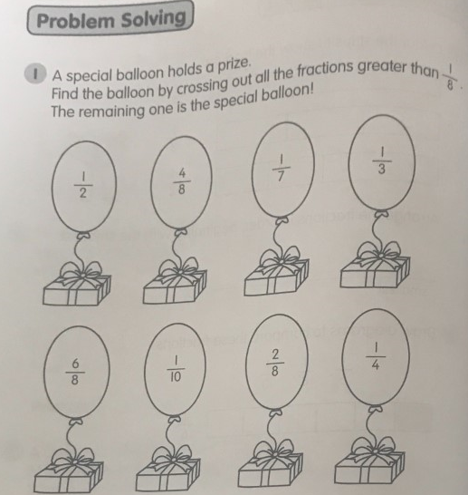

Friday 19th June 2020
Word problems with fractions
Page 7


