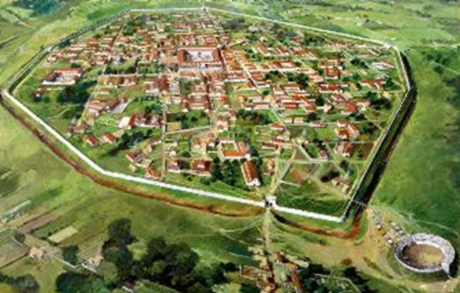
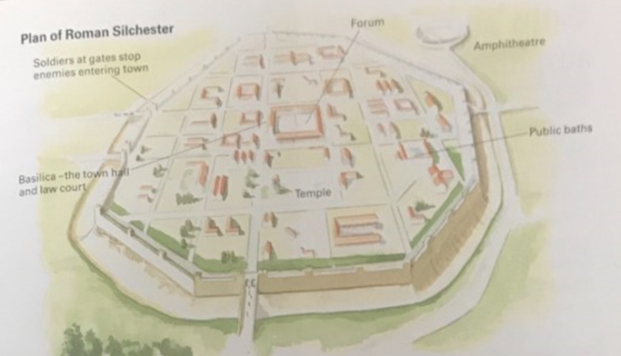

Thursday 18th June 2020
LQ: What did a Roman town look like?

Draw and label your Roman town

Make sure you include:
-baths
-forum
-amphitheatre
-basilica (the town court and the law court)
-soldiers at gates to stop enemies coming in


Thursday 18th June 2020
Forum fact file
Image:

________________________________________________________________________________________________________________________________________________________________________________________________________________________________________________________________________________________________________________________________________________________________________________________________________________________________________________________________________________________________________________________________________________________________________________________________________________________________________________________________________________________________________________________________________________________________________________________________________________
Make sure you include:
-baths
-forum
-amphitheatre
-basilica (the town court and the law court)
-soldiers at gates to stop enemies coming in

LQ: What did Roman towns look like?
Draw and label your Roman town

]]


Thursday 18th June 2020
LQ: What does a Roman town look like/

Use templates from Spicy or you can present your work in your own way. (PowerPoint, poster or fact file)

