Friday 26th June 2020
LO: To use show not tell

Read Chapter One Part Two and write a diary from the seagull’s point of view of finding the body parts and the eye. Then write about the bird seeing the Iron Man coming together.
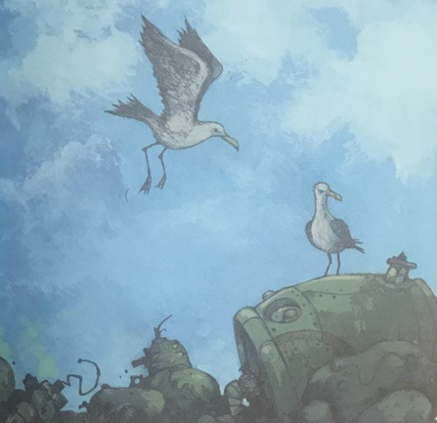

Use the success criteria below
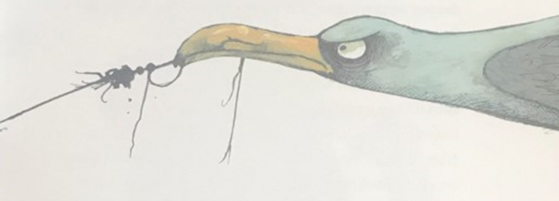
Capital letters and full stops
First person
Past tense
Use dear diary

Subordinating conjunctions
Show not tell

A range of sentence starters
Paragraphs

Wagoll

Dear Diary,

Today has been mysterious day. It all started off when the sun was majestically shining and other birds were singing sweetly. While my chicks were quietly sleeping, I looked around for food. Looming in the distance, something rusty caught a glimpse of my weary eye. Gracefully, I swooped down to see what it was. Excited and interested, intrigued and confused, I went to examine the strange object.

Glistening in front of me was an object as strange as a snail with no shell. Brightly, it was shimmering in the magnificent sunlight which made an amazing pattern on the rocky shore.

__________________________________________________________________________________________________________________________________________________________________________________
____________________________________________________________________________________________________________________________________________________________________________________
____________________________________________________________________________________________________________________________________________________________________________________
____________________________________________________________________________________________________________________________________________________________________________________
____________________________________________________________________________________________________________________________________________________________________________________
____________________________________________________________________________________________________________________________________________________________________________________
____________________________________________________________________________________________________________________________________________________________________________________ ____________________________________________________________________________________________________________________________________________________________________________________
____________________________________________________________________________________________________________________________________________________________________________________
____________________________________________________________________________________________________________________________________________________________________________________
____________________________________________________________________________________________________________________________________________________________________________________
____________________________________________________________________________________________________________________________________________________________________________________

