
Thursday 26th June 2020
LQ: Why did the Romans build roads?
Use the pictures from the slides (number 10-11) to draw and label a diagram of a Roman road. Write a sentence to explain why the roads were straight.

________________________________________________________________________________________________________________________________________________________________________


Thursday 26th June 2020
LQ: Why did the Romans build roads?
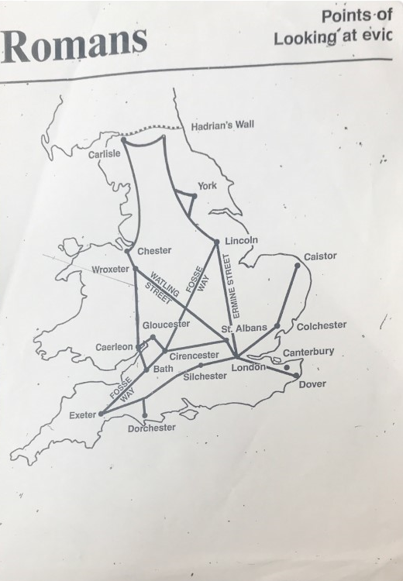

Page 2
Use the information on Page 1 to show where the main Roman roads were built in Britain.
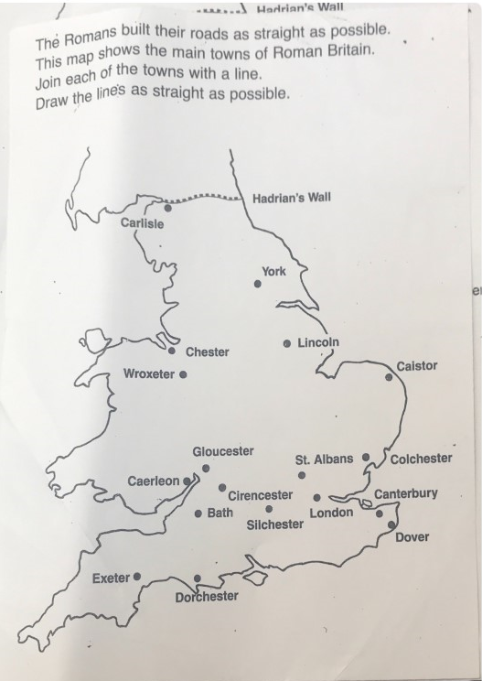

Thursday 26th June 2020

LQ: Why did the Romans build roads?
Complete the Spicy challenge and then write a paragraph to explain how the roads helped the Roman Empire and improved people’s lives.

________________________________________________________________________________________________________________________________________________________________________________________________________________________________________________________________________________________________________________________________________________________________________________________________________________________________________________________________________________________________________________________________________________________________________________________________________________________________________________________________________________________________________________________________________________________________________________________________________________________________________________________________________________________________________________________________________________________________________________________________________________________________________________________________________________________________________

