
Monday 22nd June 2020
Equivalent Fractions
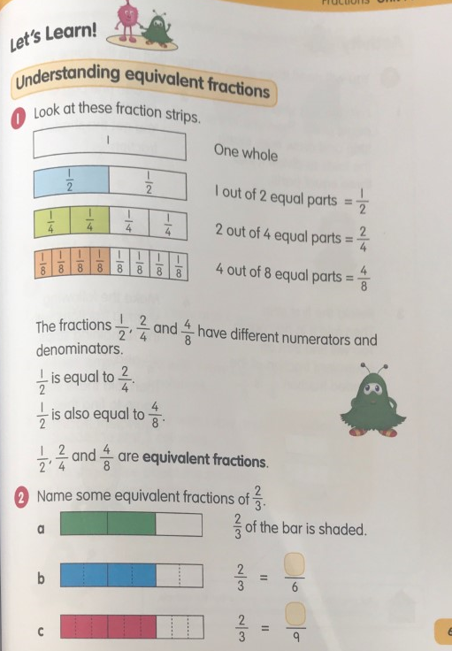
Page 1

Monday 22nd June 2020
Equivalent Fractions
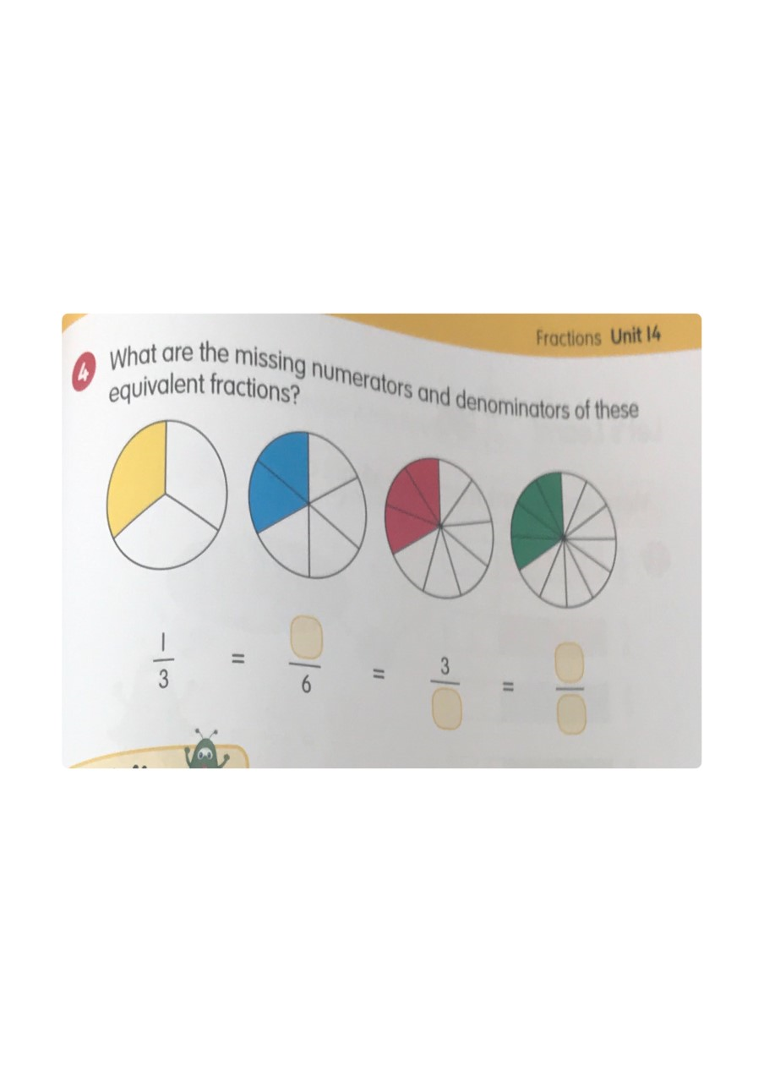
Page 2



Monday 22nd June 2020
Equivalent Fractions
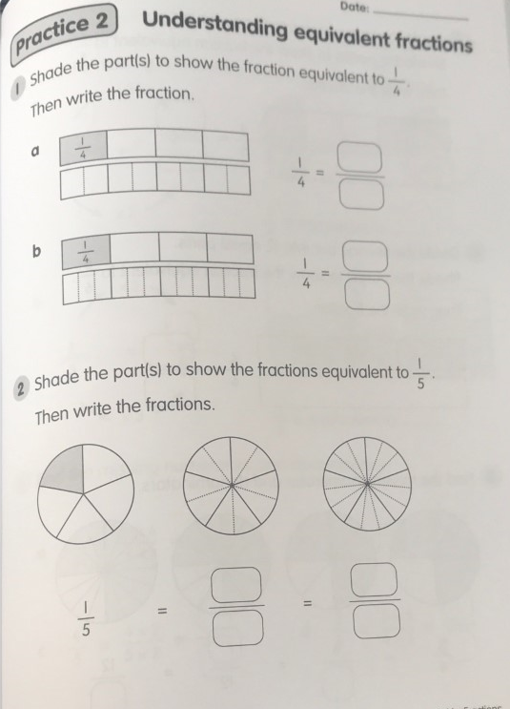
Page 3



Monday 22nd June 2020
Equivalent Fractions
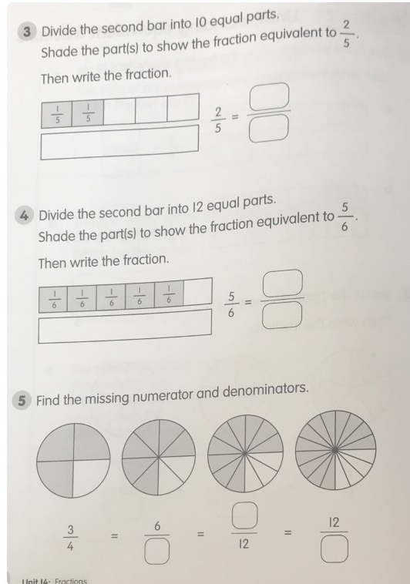
Page 4

Tuesday 23rd June 2020
Equivalent Fractions
Page 1
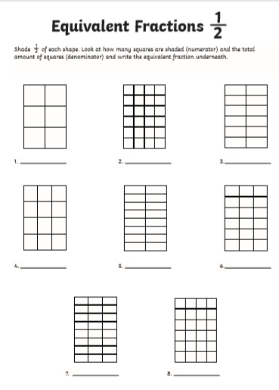

Tuesday 23rd June 2020
Equivalent Fractions
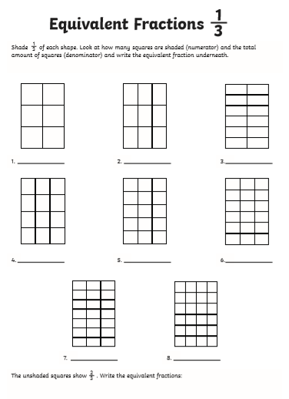
Page 2

Tuesday 23rd June 2020
Equivalent Fractions
Page 3
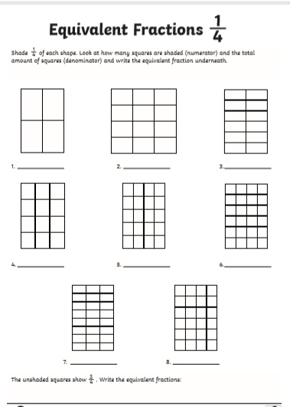

Tuesday 23rd June 2020
Equivalent Fractions
Page 4
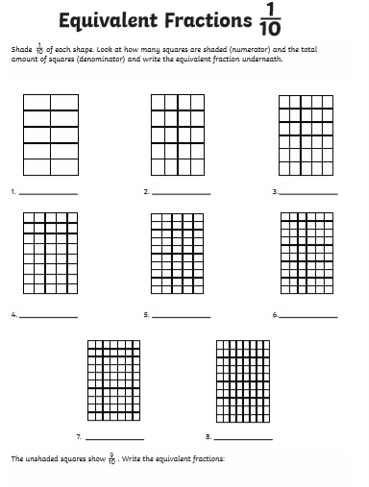

Tuesday 23rd June 2020
Equivalent Fractions
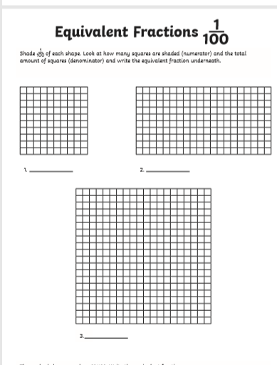
Page 5

Wednesday 24th June 2020
Equivalent Fractions
Page 1
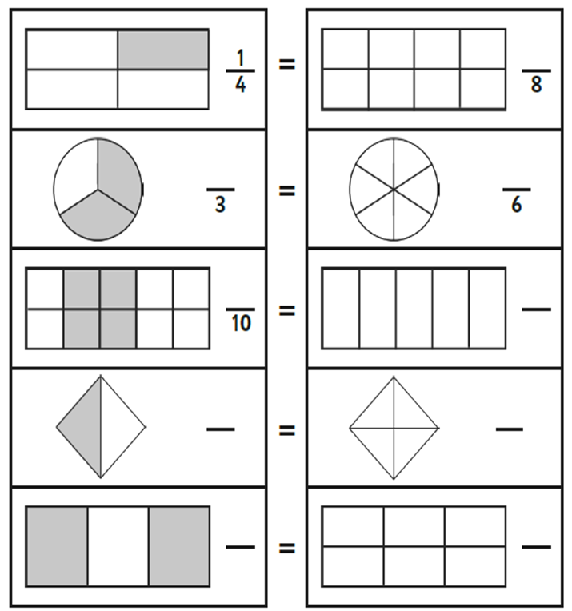

Wednesday 24th June 2020
Equivalent Fractions
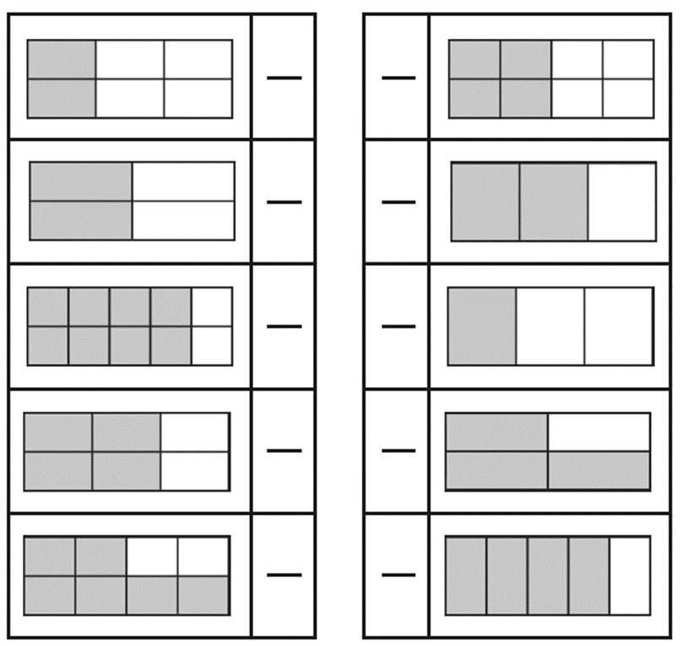
Page 2

Wednesday 24th June 2020
Equivalent Fractions
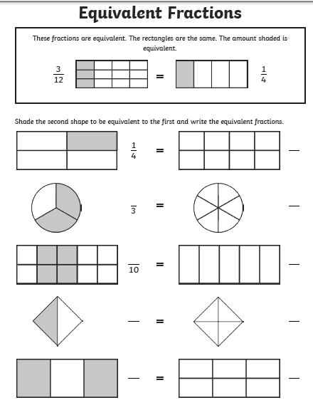
Page 3

Wednesday 24th June 2020
Equivalent Fractions
Page 4
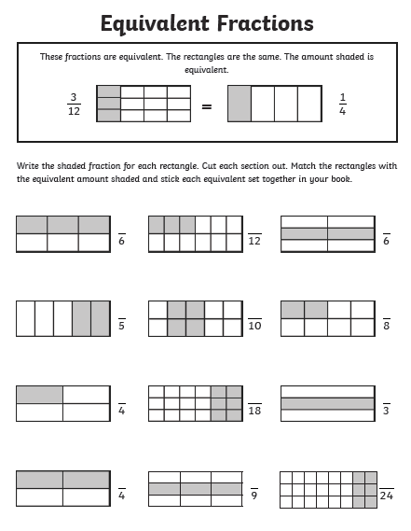

Thursday 25th June 2020
Short cut equivalent fractions
Page 1
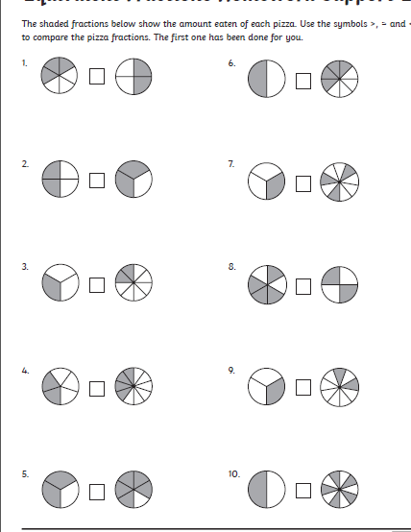

Thursday 25th June 2020
Short cut equivalent fractions
Page 2

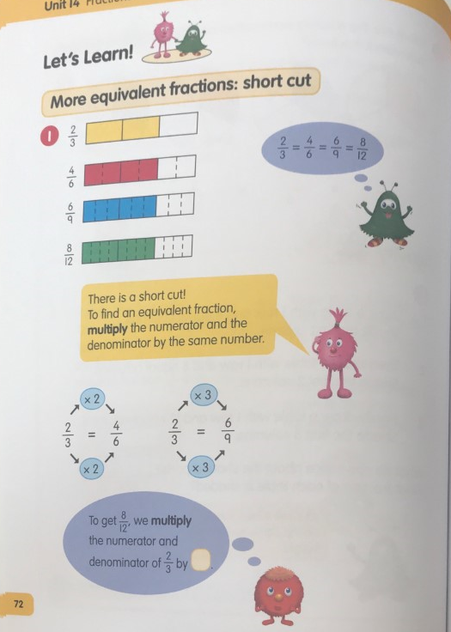

Thursday 25th June 2020
Short cut equivalent fractions
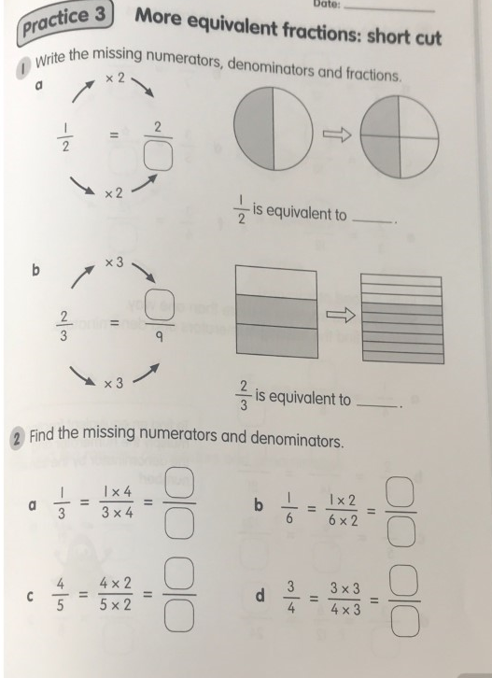
Page 3

Thursday 25th June 2020
Short cut equivalent fractions
Page 4
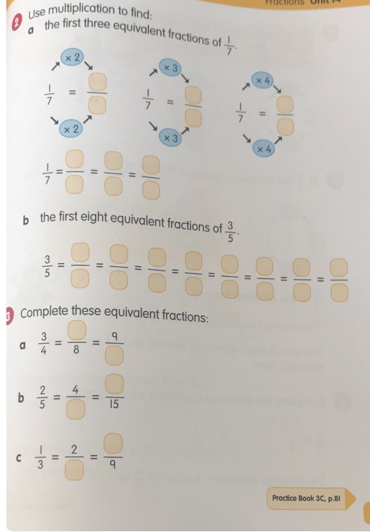

Thursday 25th June 2020
Short cut equivalent fractions
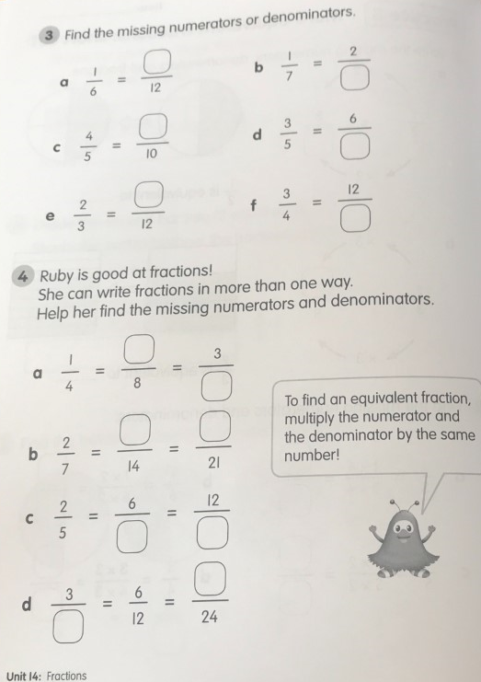
Page 5

Friday 26th June 2020
Short cut equivalent fractions
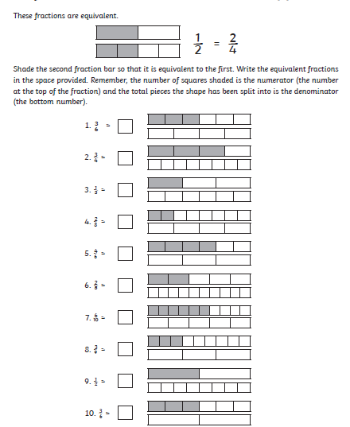
Page 1

Friday 26th June 2020
Short cut equivalent fractions
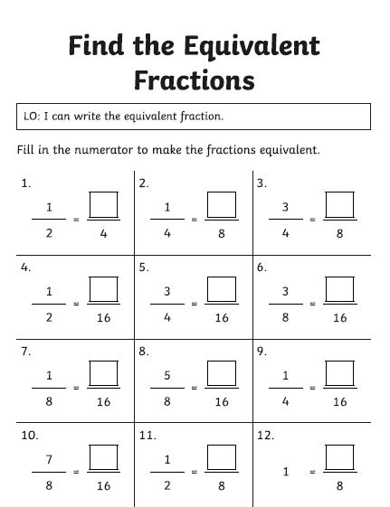
Page 2

Friday 26th June 2020
Short cut equivalent fractions
Page 3
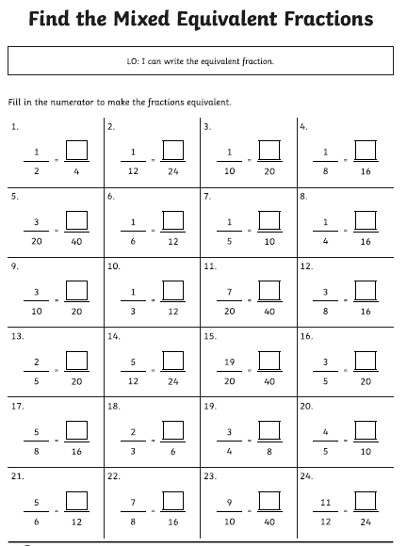

Friday 26th June 2020
Short cut equivalent fractions
Page 2


