Building confidence and resilience in children

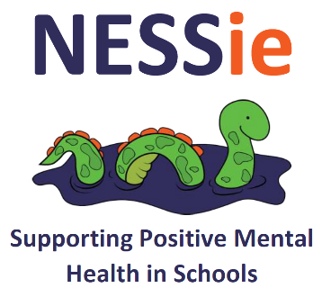



nessieined.com

OVERVIEW
A remote Parent/Carer forum to help parents support their children at home and returning to school.
Getting the right help to you and your child.
This online forum is designed to help parents support their children whilst at home and transitioning back to school.
The aim of the session is to help develop a better understanding of feelings and the ways in which we can support children develop confidence and resilience. This training would be suitable for parents and carers with children up to age 13.

DATE & TIME
Wednesday 8th July 2020
1.30-2.30pm
This event is free to attend for parents/carers within Stevenage
TO BOOK A PLACE PLEASE CLICK HERE

