Monday 29th July 2020
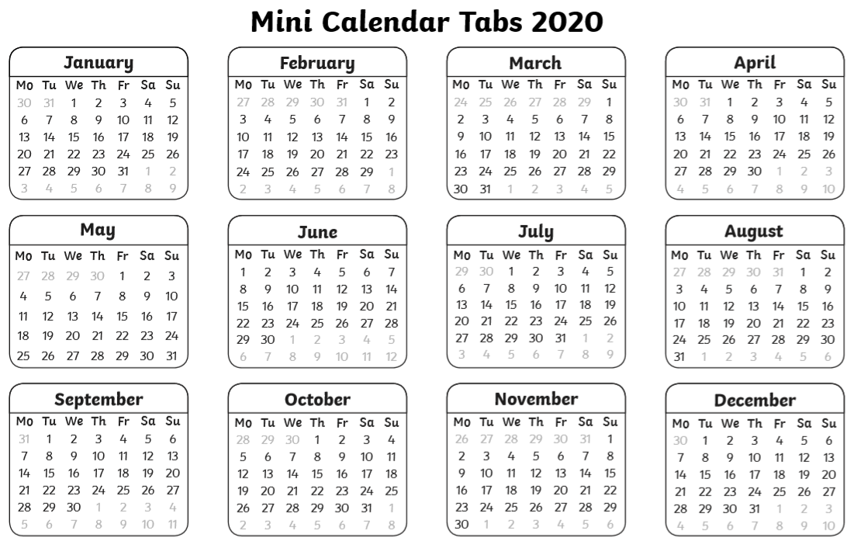
LO: To say how many days there are in months, a year and a leap year
2020 Calendar

