
Monday 29th June 2020
LO: To say how many days there are in months, a year and a leap year

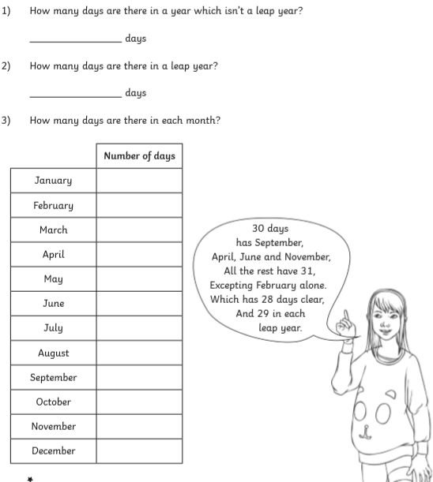

Monday 29th June 2020
LO: To say how many days there are in months, a year and a leap year

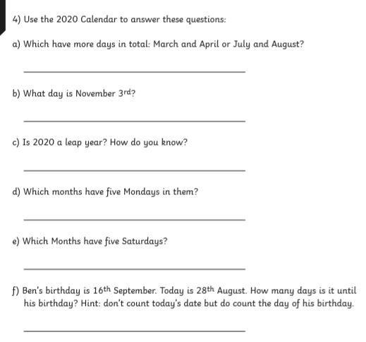


Monday 29th June 2020
LO: To say how many days there are in months, a year and a leap year
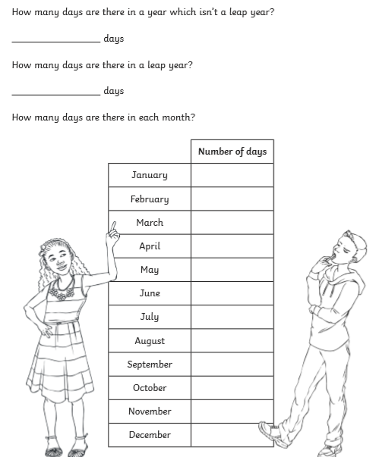

Monday 29th June 2020
LO: To say how many days there are in months, a year and a leap year

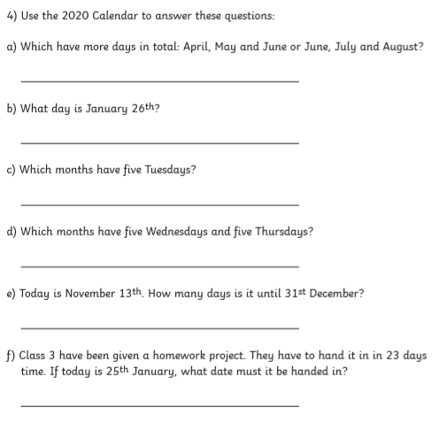


Monday 29th June 2020
LO: To say how many days there are in months, a year and a leap year

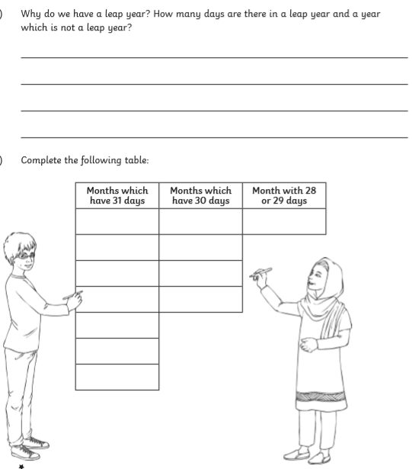

Monday 29th June 2020
LO: To say how many days there are in months, a year and a leap year



