Thursday 2nd July 2020
LO: To tell the time

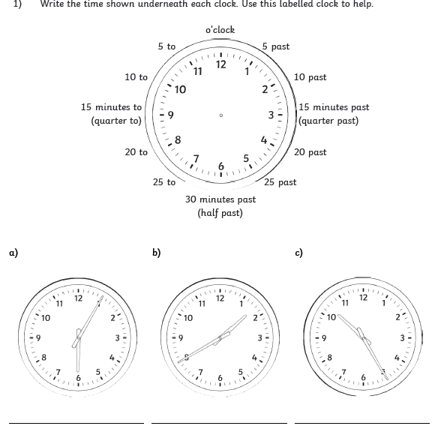

Thursday 2nd July 2020
LO: To tell the time
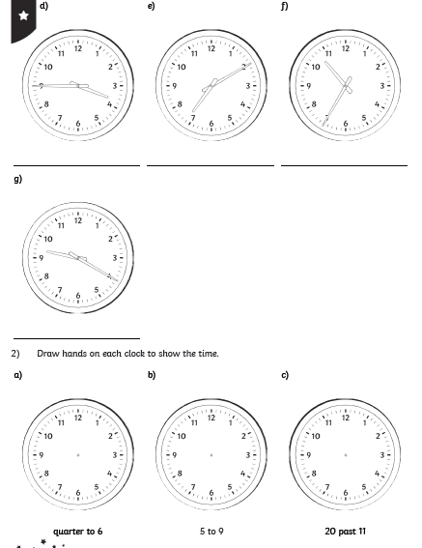

Thursday 2nd July 2020
LO: To tell the time

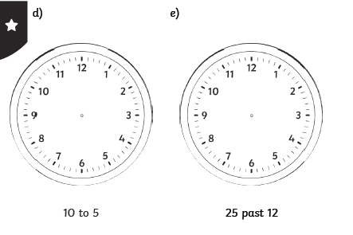

Thursday 2nd July 2020
LO: To tell the time
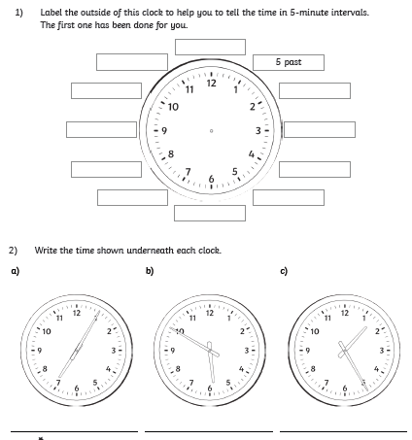

Thursday 2nd July 2020
LO: To tell the time
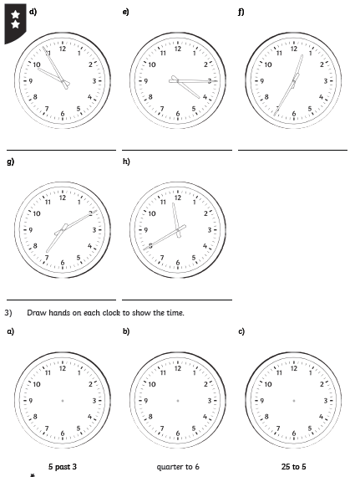

Thursday 2nd July 2020
LO: To tell the time
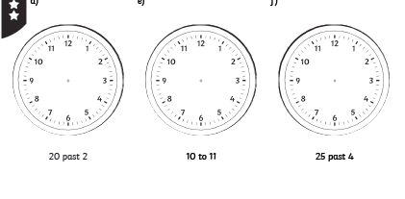

Thursday 2nd July 2020
LO: To tell the time
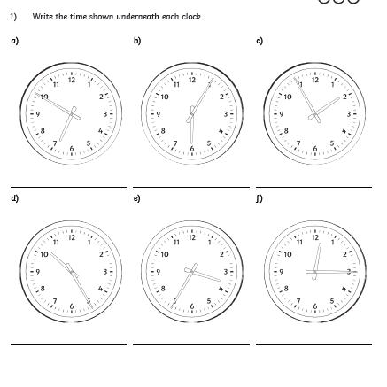

Thursday 2nd July 2020
LO: To tell the time
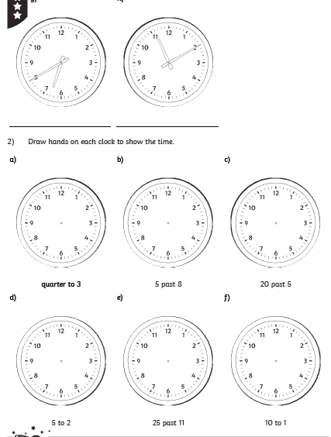

Thursday 2nd July 2020
LO: To tell the time


