
Tuesday 30th June 2020
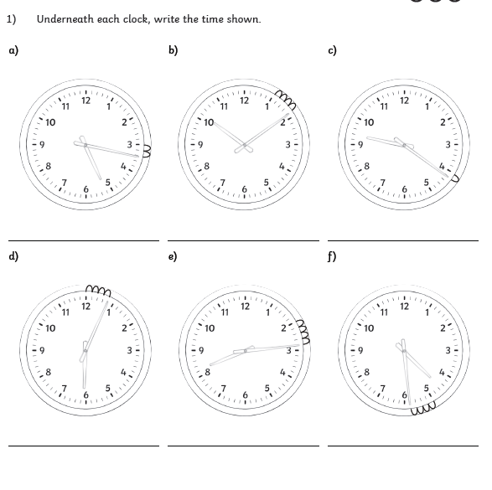
LO: To tell the time

Tuesday 30th June 2020
LO: To tell the time

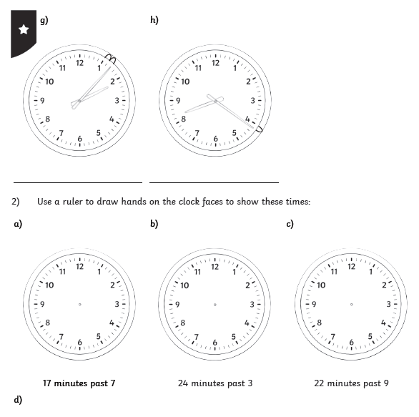


Tuesday 30th June 2020
LO: To tell the time

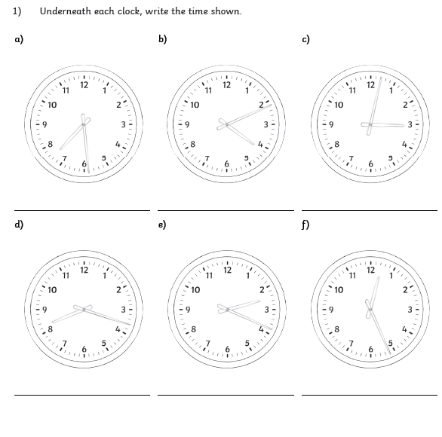

Tuesday 30th June 2020
LO: To tell the time

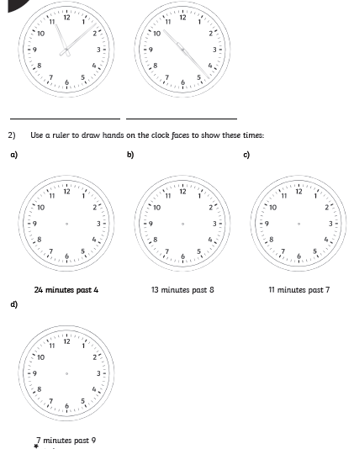


Tuesday 30th June 2020
LO: To tell the time
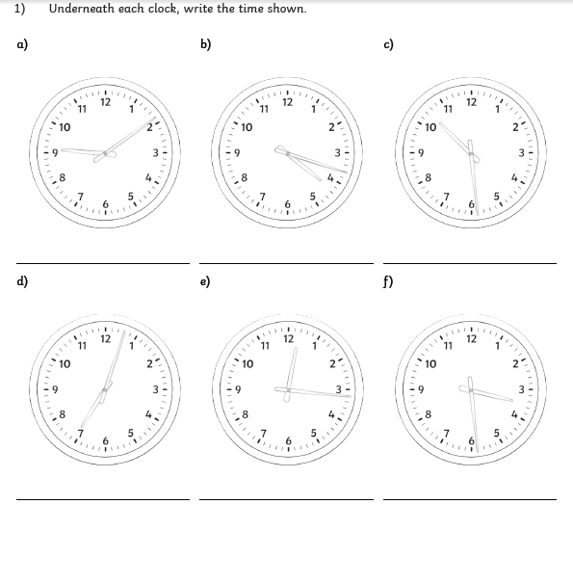

Tuesday 30th June 2020
LO: To tell the time


