Wednesday 1st July 2020
LO: To tell the time
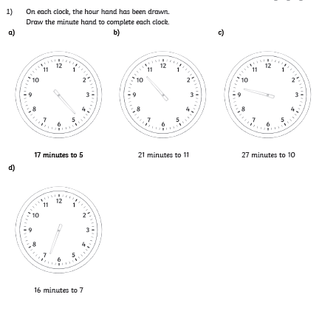

Wednesday 1st July 2020
LO: To tell the time

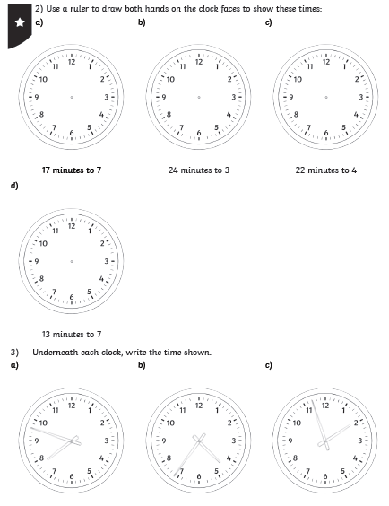

Wednesday 1st July 2020
LO: To tell the time

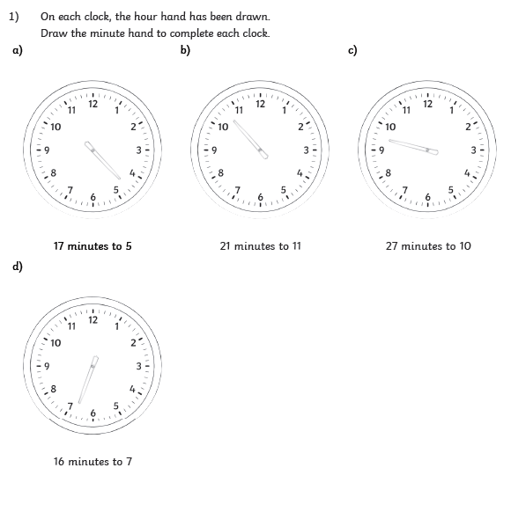

Wednesday 1st July 2020
LO: To tell the time
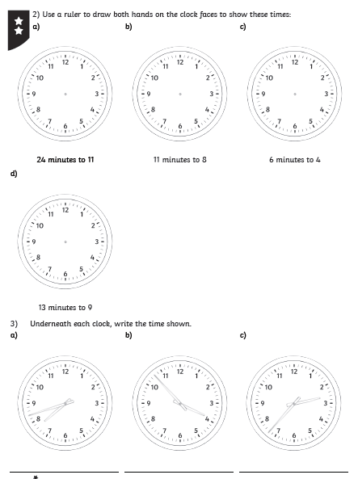

Wednesday 1st July 2020
LO: To tell the time
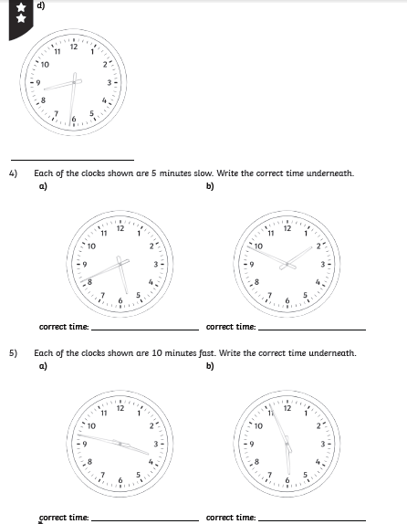

Wednesday 1st July 2020
LO: To tell the time

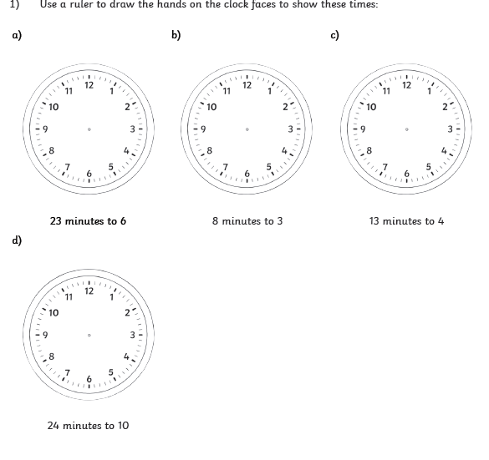

Wednesday 1st July 2020
LO: To tell the time
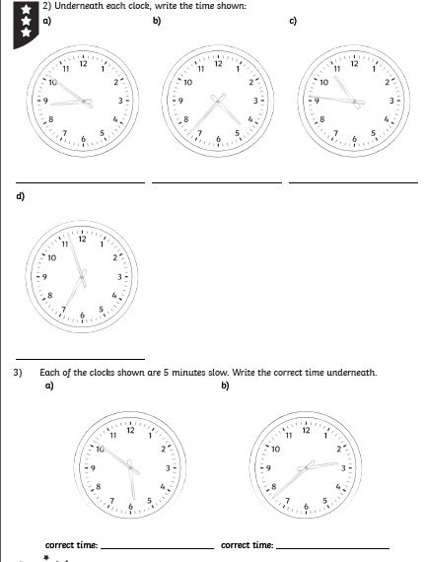

Wednesday 1st July 2020
LO: To tell the time


