
Monday 29th June 2020
LO: To identify features of a letter

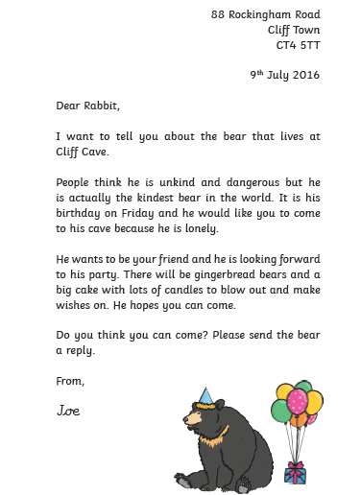

Mild Checklist

Underline each feature in a different colour and tick the correct box in the same colour.

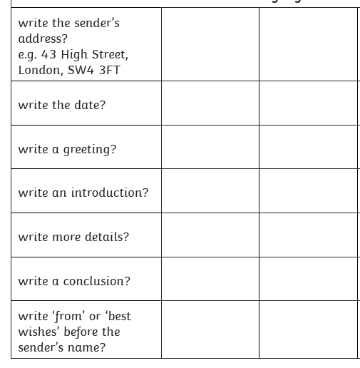


Monday 29th June 2020
LO: To identify features of a letter
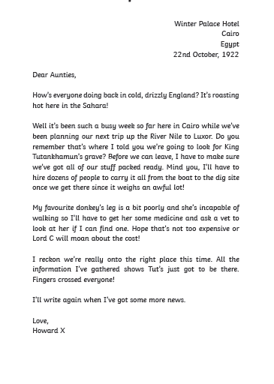

Spicy Checklist

Underline each feature in a different colour and tick the correct box in the same colour.
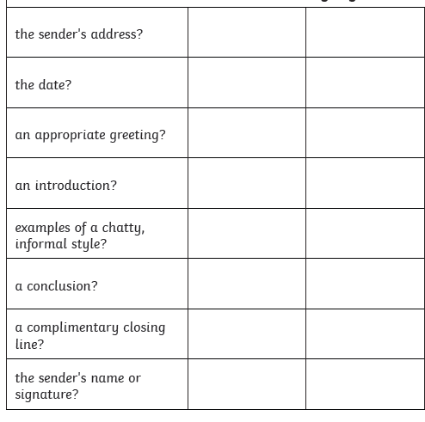



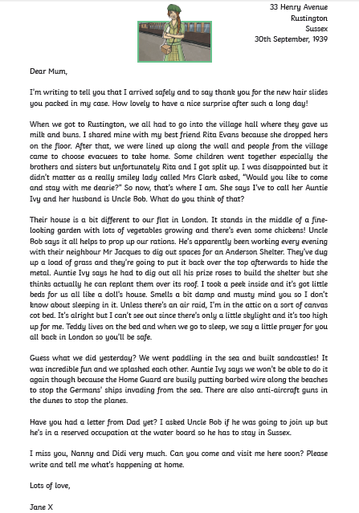

Monday 29th June 2020
LO: To identify features of a letter

Hot Checklist

Underline each feature in a different colour and tick the correct box in the same colour.



