Tuesday 30th June 2020
LO: To use conjunctions

Choose which activity you want to do! Either extra mild, mild, spicy, hot or super hot!!
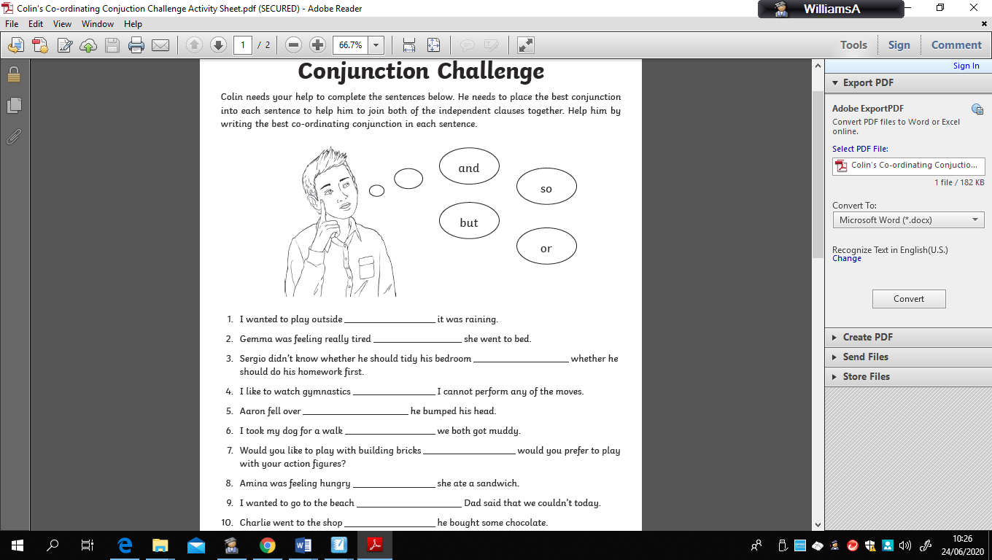

Tuesday 30th June 2020
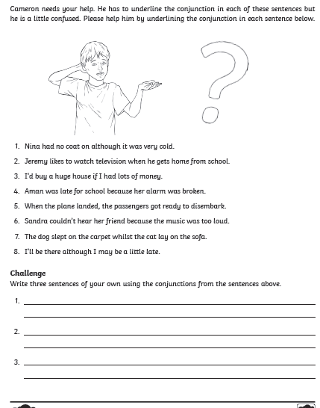
LO: To use conjunctions


Tuesday 30th June 2020
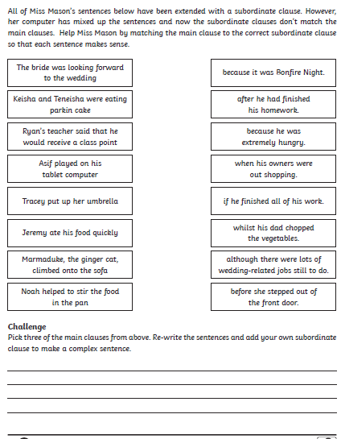
LO: To use conjunctions


Tuesday 30th June 2020
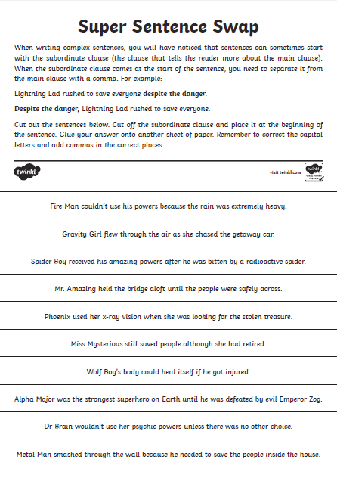
LO: To use conjunctions

Tuesday 30th June 2020
LO: To use conjunctions


