
Wednesday 1st July 2020
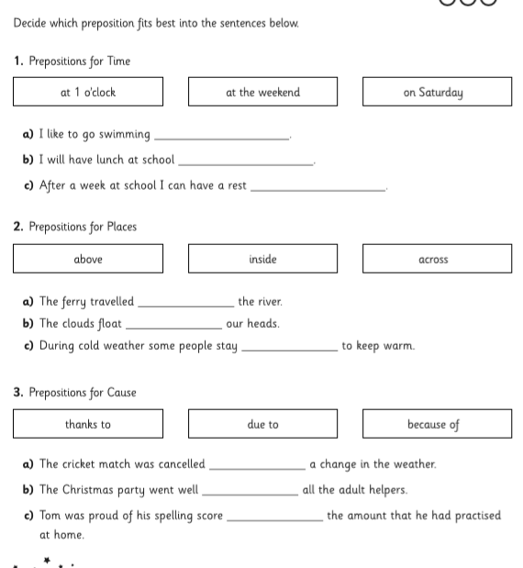
LO: To use prepositions


Wednesday 1st July 2020
LO: To use prepositions
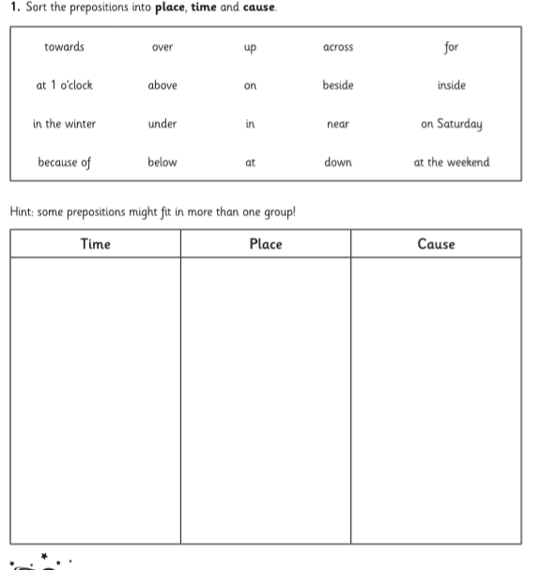


Wednesday 1st July 2020
LO: To use prepositions

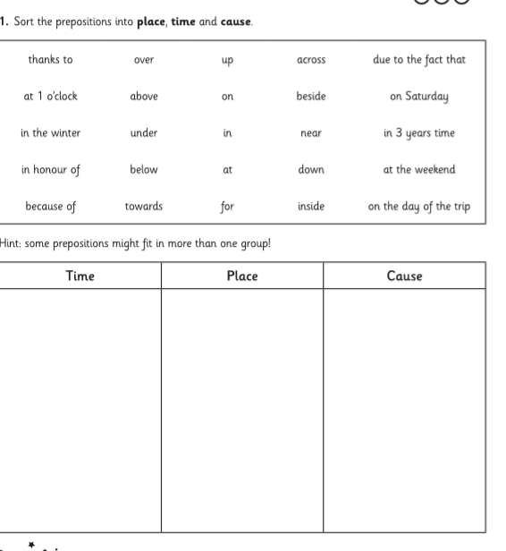

Wednesday 1st July 2020
LO: To use prepositions

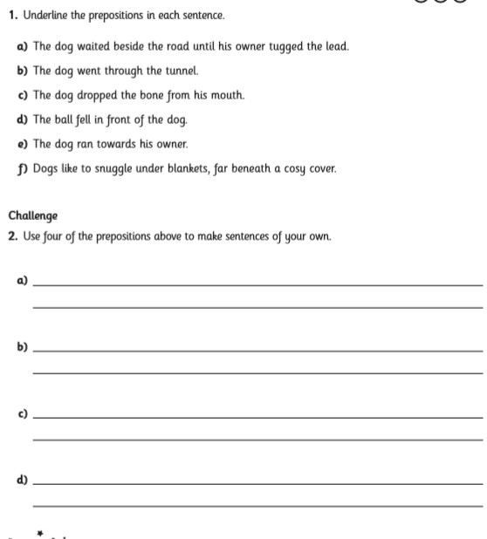



Wednesday 1st July 2020
LO: To use prepositions


