Week 7
Literacy w/b 13th July
Day 1
It is the last week of term! You have done so well and we are very proud of you!
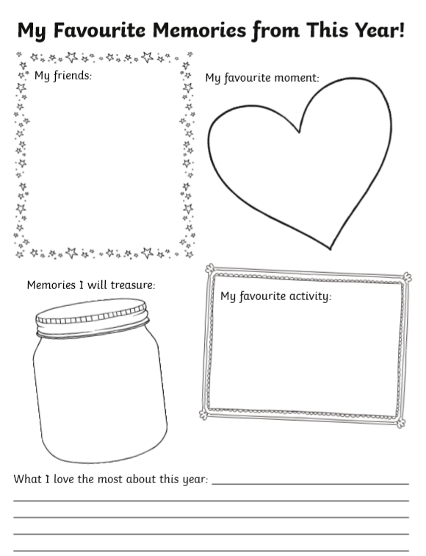
Please complete the activity below with some memories from this year.

