Week 7 - w/b 13th July
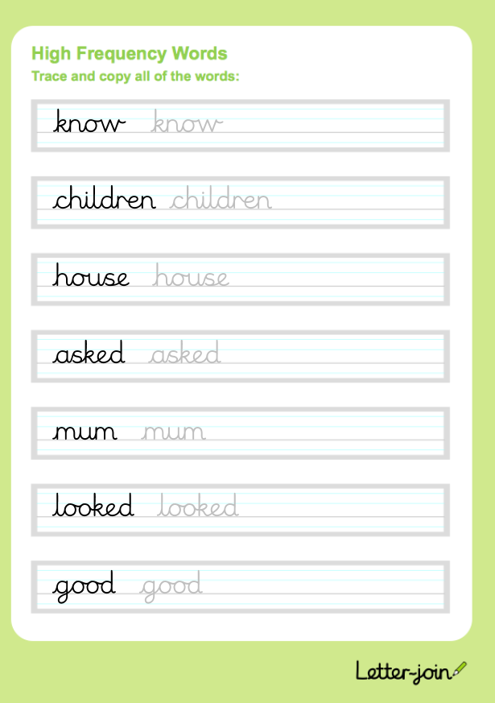
Day 2 Handwriting

