Week 7
Literacy w/b 13th July
Day 2
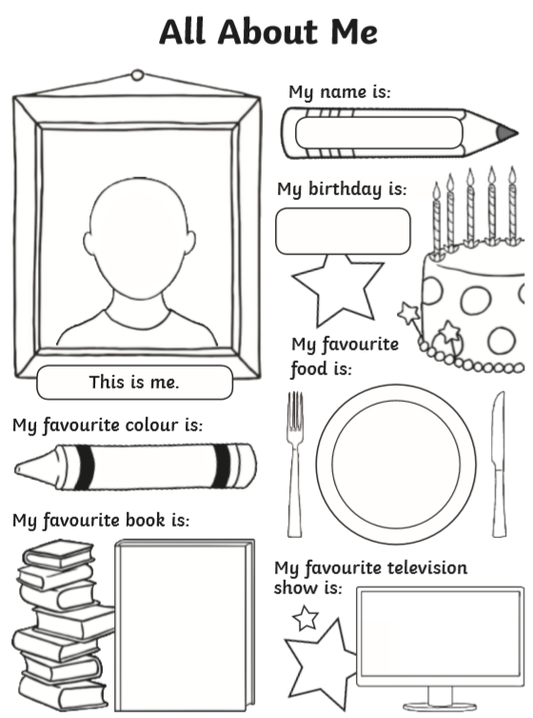
Fill out this sheet with information all about you! This will be given to your new teacher so that they can learn a little bit about you!

