We made it to the last day
We hope you have a fantastic summer!
Today we have included a fun pack of activities for you to do – all about summer. There is a spot the difference, maze, poem activity, cross word and word search.
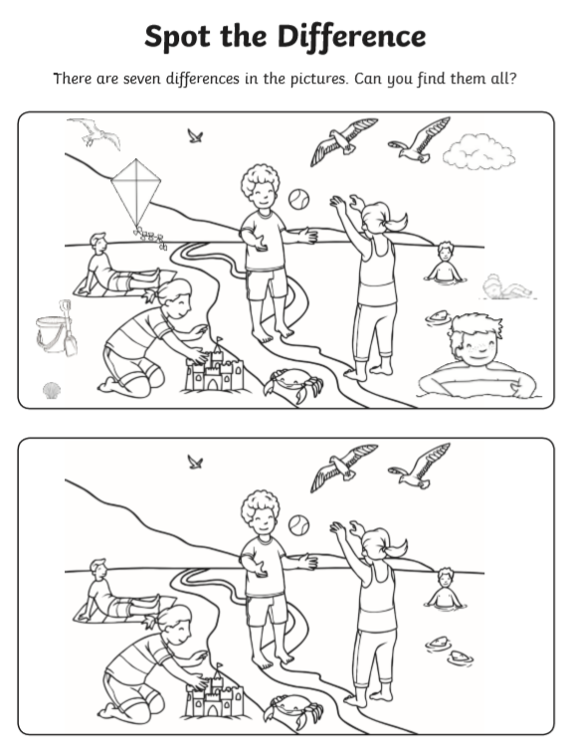
Have a fantastic summer!


