Week 7 - w/b 13th July
Day 3 Maths
Today we continuing to learn about money.
Can you read the amounts below and write the amount using p and £?
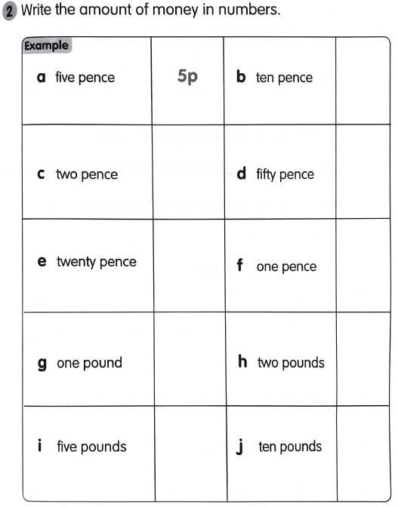

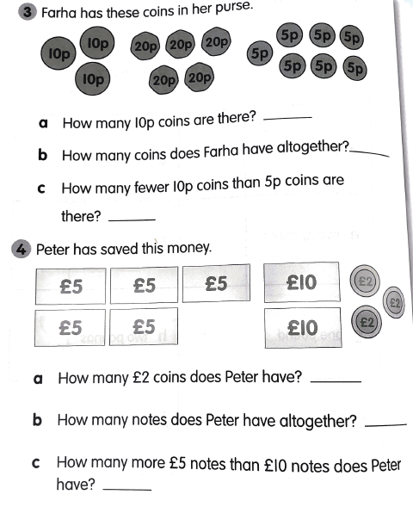

We are looking at amounts.
To make 2p we need 2 1ps.
To make 5p we need 5 10ps.
Using this, can you work out the exchanges below?


