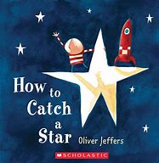
Week 7 – w/b 13th July
Mindset and DT
Please use this website to listen to the stor ‘How to catch a star’ by Oliver Jeffers
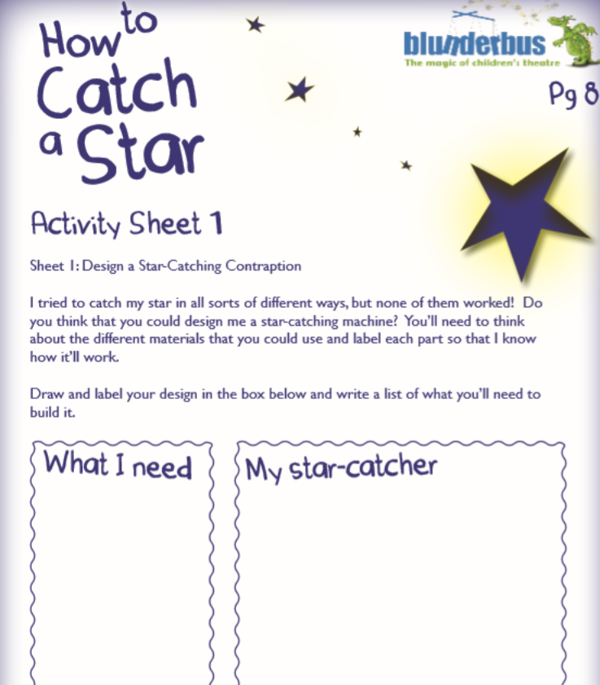
https://www.youtube.com/watch?v=rpyR6hJPxiw
We would like you to design your own star catcher. If you have things at home you can use, you could even make your own one!

