Stevenage Music Service – Instrumental Lessons
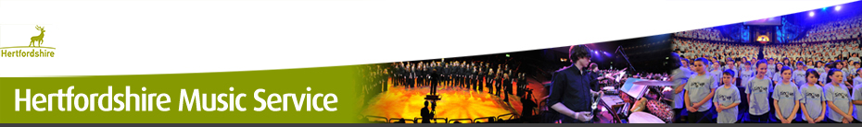

The Stevenage Music Service currently offer Violin and Guitar lesson to children at Roebuck Academy. The lessons are for 30 mins each week and due to Covid restrictions this year will be taught in year group bubbles.
These lessons are available to KS2 children only. Instruments are provided by the music service, however if you have your own instrument you may use this in your lesson.
To apply for a place please follow the link below to register your child’s details.
This year we have moved to direct billing where the Stevenage Music Service handle all of the payments. If you need help or advice please speak with Miss Whitfield or Mrs Solomon.

http://www.hertsmusicservice.org.uk/registeronline

