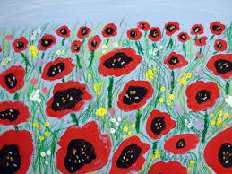
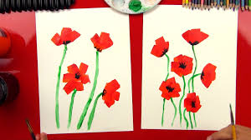
Half-Term Topic Homework WW1– Year 4.
Remember to make sure that you read at least Five times during half-term! Choose one of these activities as well to do this half term. You can be as creative as possible.
Make a 3D Poppy of your own.  Choose your own way to make this. | Make a storyboard about the ‘Battle of the Somme’ | Draw or paint a picture of someone important in WW1. (eg a soldier, nurse etc)
Write a diary entry from the point of view of an evacuee from WW1. | Make your own Anderson/ Evacuation model shelter | Write ten facts about WW1 and present them in an interesting poster  (ICT or colourful pens)
