Roebuck Academy- home reading (5 times a week)
At Roebuck we know how vital reading is for our children. Our homework policy is to read at least 5 times per week at home, however, we know that it can be difficult to access a range of appropriate books when home learning. With this in mind we have purchased a new reading scheme that is online and has hundreds of books pitched correctly for your child’s needs and ability.
The scheme is reading planet and comes from Rising stars. Below are instructions about how to log in and navigate the wonderful resources.
All children have been given an account and will use their same log in details that they use to access purple mash. This can be found in your child’s reading record.
First use the web address below to get to the log in page for rising stars…
https://my.risingstars-uk.com/Default.aspx?testid=17772&u=84f03b3b-51b1-4590-a2b9-05501cd3df67
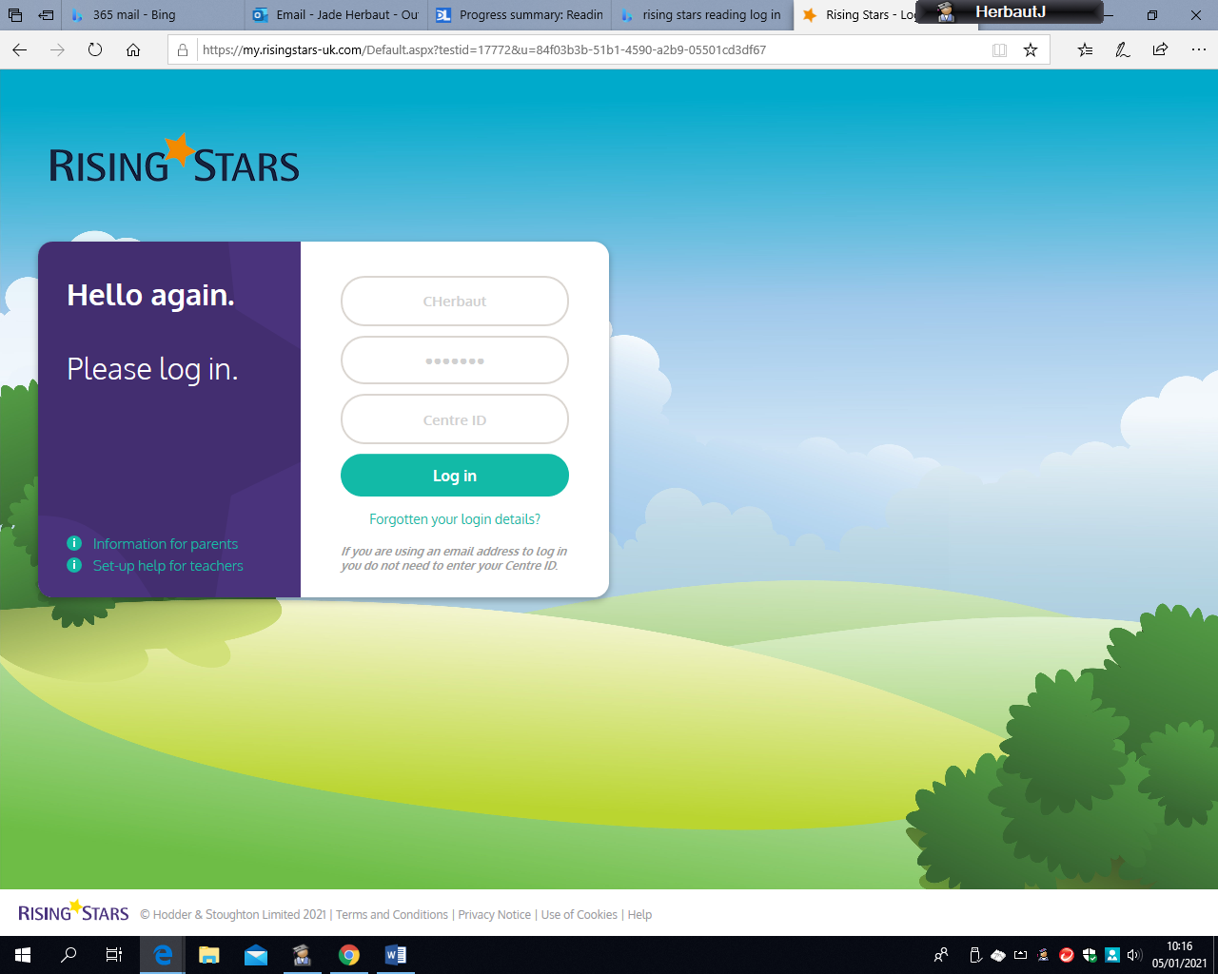
Use your child’s purple mash log in details (this is stuck in your child’s reading record) and the ID number for our school is 257472
Then you will choose the key stage that your child is in either KS1 or KS2 (if your child is in EYFS you will choose KS1 as these books have the beginning reading colours)

When you have completed log in you will see your child’s profile page with their name at the top and all the books you have available listed below and will be able to access these immediately. In KS1 children’s books will also indicate the colour book band so that you can choose the correct level that your child reads at school.
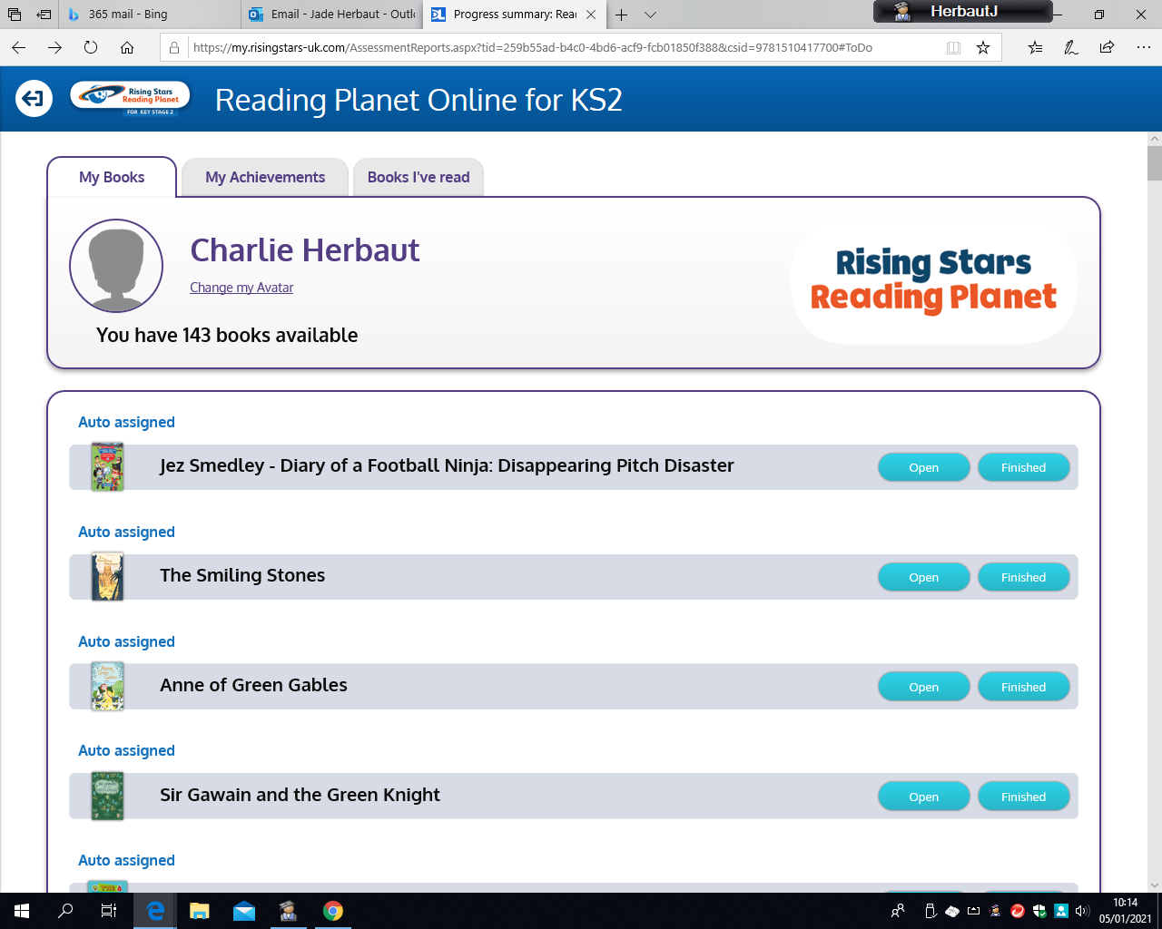
Each ebook that you read has one or more checkpoint quizzes that appear at intervals throughout the book. These quizzes are to check children’s understanding. They are indicated with an animated quiz icon that is shown on the screen.
At the end of the book there is a longer quiz. The children will receive a bronze, silver or gold star when they are finished.
Teachers will be able to see how and when the children have logged on, how many books they have read and how they get on with the quizzes.
We really hope the children love the range of books on offer and enjoy the quizzes to support their learning.
We will also send a more detailed pack about Reading planet for each key stage that will support you in understanding the coloured bands for KS1 and the options available for KS2 children.
The My Achievements tab will show you how you are doing through awarding gold, silver and bronze stars as you complete quizzes.

