Monday 22nd June 2020
Equivalent Fractions
Page 1

Monday 22nd June 2020
Equivalent Fractions
Page 2

Monday 22nd June 2020
Equivalent Fractions
Page 3

Monday 22nd June 2020
Equivalent Fractions
Page 4

Tuesday 23rd June 2020
Equivalent Fractions
Page 1

Tuesday 23rd June 2020
Equivalent Fractions
Page 2

Tuesday 23rd June 2020
Equivalent Fractions
Page 3

Tuesday 23rd June 2020
Equivalent Fractions
Page 4

Tuesday 23rd June 2020
Equivalent Fractions
Page 5

Wednesday 24th June 2020
Equivalent Fractions
Page 1
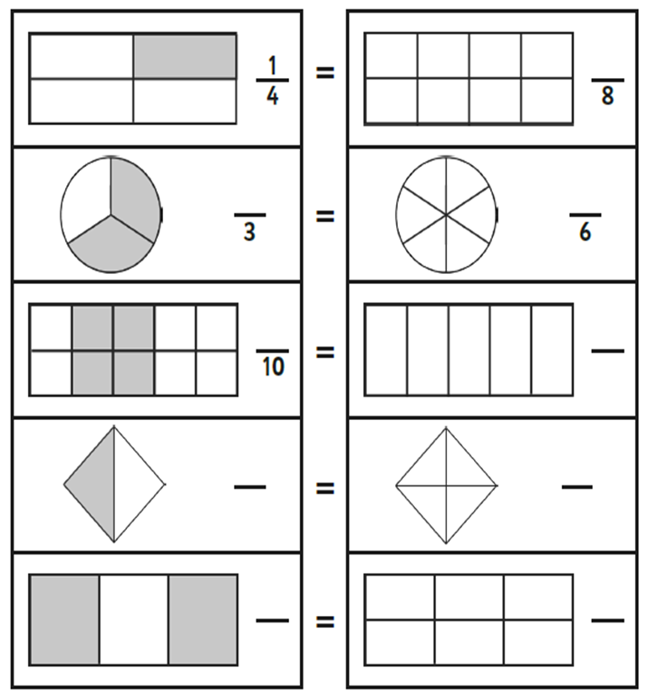

Wednesday 24th June 2020
Equivalent Fractions
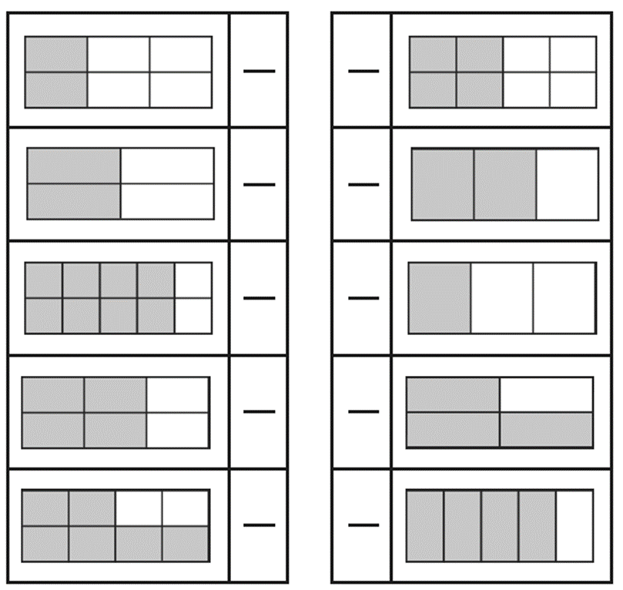
Page 2

Wednesday 24th June 2020
Equivalent Fractions
Page 3

Wednesday 24th June 2020
Equivalent Fractions
Page 4

Thursday 25th June 2020
Short cut equivalent fractions
Page 1

Thursday 25th June 2020
Short cut equivalent fractions
Page 2

Thursday 25th June 2020
Short cut equivalent fractions
Page 3

Thursday 25th June 2020
Short cut equivalent fractions
Page 4

Thursday 25th June 2020
Short cut equivalent fractions
Page 5

Friday 26th June 2020
Short cut equivalent fractions
Page 1

Friday 26th June 2020
Short cut equivalent fractions
Page 2

Friday 26th June 2020
Short cut equivalent fractions
Page 3

Friday 26th June 2020
Short cut equivalent fractions
Page 2

